|  |
| --- |
| Arbetsrapport XXXX-YYYY |
| Aerial drones for thinning – a desk study |
|  |
| Jonas Cedergren, Line Djupström, Lars Eliasson, Emelie Fredriksson, Magnus Person & Petter Öhrn |

|  |
| --- |
|  |

Bildtext anges här.

Foreword 5

Summary 6

Technical perspectives 7

Pest control perspectives 7

Effects on stand production 7

Biodiversity aspects 8

Sammanfattning 9

1. Introduction 12

Thinning – a brief review 12

General thinning practices 13

Finally 13

Objectives 14

2. Silvicultural aspects of drones in thinning 14

Assumptions 14

Broadleaves 15

The residual stand 15

Bioenergy 17

Technical comments 17

3. An operational evaluation of drones in thinning 17

Material and method 19

Results 20

Discussion 24

4. Airborne drones in forestry from a biodiversity standpoint 25

Background 25

Method 26

Results 26

Strip roads and soil impact 26

Conclusion 29

5. Effects on growth, stand development and stand economy – simulations in Heureka 29

Background 30

Objective 30

Materials 30

Method 31

Assumptions 31

Simulations 31

Land Expectation Value 33

Result variables 33

Results 33

Thinning regime 33

Growth 37

Harvest 37

Discussion 39

Simulations 39

Future forest management trends affecting thinning 39

Bark beetles in a changing world 40

Bark beetle life cycle and phenology 40

Techniques for early detection of bark beetle infested trees 42

Use of harvest drones as a pest management tool 42

Pest control measures and modelling of bark beetle populations 43

7.Concluding remarks 43

APPENDIX 53

Glossary 53

|  |
| --- |
| Logotyp  Uppsala Science Park, 751 83 Uppsala  skogforsk@skogforsk.se  skogforsk.se |
| Kvalitetsgranskning (Intern peer review) har genomförts xx månad xxxx av  Xx xx, titel. Därefter har Magnus Thor, Forskningschef,  granskat och godkänt publikationen för publicering xx månad xxxx.  Redaktör: Anna Franck, anna@annafranck.se  **©Skogforsk 2021** ISSN 1404-305X |

# Foreword

This report presents the results of a study whose main objective is to evaluate the feasibility of an airborne system for thinning in Fennoscandian forests, conducted through a desk study. The system is based on unmanned aerial vehicles, drones. The evaluation is conducted from technical, environmental, and silvicultural perspectives.

The study is part of the ongoing work at Air Forestry AB to develop a drone-based system for forest thinning. It is important to emphasize that the study assesses the general usefulness of drones for thinning. It is not an evaluation of the Air Forestry system currently under development.

The funding for this study has been provided by Vinnova. This report aims to illuminate the technical, environmental, and silvicultural aspects of using drones in thinning operations. By deepening our understanding of these factors, we can contribute to shaping future strategies for sustainable forestry and technological innovation within the forestry industry.

We would like to express our gratitude to Vinnova for their support and the opportunity to conduct this study. We hope that the results of this evaluation will contribute to the ongoing dialogue on the use of drone technology in the forestry sector and open doors for further research and development in the field.

Readers will note that the document that forestry-related terminology is in no short supply in the document. A glossary to help readers understand the text is found in the Appendix.

# Summary

The objective of the present study is to, by means of a desk study, evaluate the usefulness/potential of an airborne system in thinning operations in forests of Fennoscandia. The system is based on unmanned aerial vehicles (hence referred to as drones). The potential is evaluated from a technical, environmental and a silvicultural standpoint. Thinning is a common silvicultural treatment in Sweden. The first thinning is typically done when a stand has a dominant height of 10-15 metres. There are different forms or methods of thinning. Thinning from below where smaller trees are removed, uniform thinning where trees from all crown classes are removed, and thinning from above where larger trees are removed. Some 300 000-350 000 ha are thinned every year, and roundwood from thinnings makes up some 20-25 percent of the annual roundwood harvest. Issues of concern in connection to thinning include:

* Thinnings tend to be done too late in the rotation, resulting in growth losses
* Future stand development is too often impeded by neglect of pre-commercial thinning, making thinning difficult
* Spread of root rot in connection to thinning due to mechanical damage from tires on roots and logging damage to stems
* Logging damage and ground damage by heavy machinery

An obvious benefit from an air-based thinning system is that no strip roads are needed. Strip roads tend to cover around 18 per cent of stands thinned, an area cleared with associated production losses. Studies indicate a production loss of 5-10 per cent during a period of 15 to 20 years. Many trees harvested in first thinning are mandatory trees, i.e. strip road trees, suppressed and/or damaged trees. Thinning done using an airborne system can be more selective, but broadleaves, big and deformed trees may pose problems due to inherent limitations of airborne systems with harvester heads.

Nurse crops, a crop of trees or shrubs that foster the development of another tree species by protecting the second species, could see an increased use if airborne system become an option. Nurse crops offer frost protection to seedlings, control of groundwater, increase growth and yield by 10 to 15 percent over a rotation and enhance seedling survival. Establishment and removal of nurse crops using normal systems is difficult and expensive, and done mainly to protect seedlings from frost. Logging damage levels and operational economics have limited the use of nurse crops. With airborne systems damage could probably be held at acceptable levels, and the recurrent operations needed could be economically more viable. This would enable wider use of nurse crops, not only for frost protection, but also for, over the rotation, higher production.

Diameter distribution in drone thinned stands will be wider than in stands thinned with normal systems. Broadleaves, big and deformed trees may be difficult to remove, and so will also small trees not visible from above. This effect can be reduced by restricting use of airborne systems to stands with few broadleaves, big and deformed trees.

An airborne system is an interesting option for removing spruce trees from sensitives site like protected areas, buffer zones, and cultural heritage sites.

Alternatives of the system are worth considering, e.g. using grapples instead of harvester heads, with harvesters working from ghost trails doing the harvesting. Problems with big and/or deformed trees and broadleaves may be eliminated in such a system. Moreover, a grapple is not as heavy as a harvester head, thus enabling larger pay loads.

## Technical perspectives

Thinning with a machine that booth fell and delimb a selected tree while airborne and subsequently lift it to the landing is a new concept and the evaluation was done using simulation techniques. Given the assumptions made such a system, with only one drone, is not likely to be economically competitive with a conventional thinning system, using a harvester and forwarder. This may change if the operator can manage multiple drones simultaneously. Result can be summarised as:

* Drone productivity is sensitive to tree weight with an optimum load volume being close to the maximum payload
* Drone productivity is sensitive to transport distance, especially for loads consisting of a small tree
* Small trees give low productivity. It will be difficult to position the harvester head to delimb and cut small trees positioned close to larger future crop trees. This was not considered in the simulations, and will cause further reductions in productivity
* The desired extraction rates will be difficult to reach in thinning stands with a large variation in tree sizes, especially when the average stem weight is close to the safe pay loads.

## Pest control perspectives

During the last decades there has been a strong increase in disturbances of tree-killing bark beetles in all the world’s coniferous forests leading to large losses of economic and ecosystem values. Following the drought event in 2018 there has been an unprecedented spruce bark beetle outbreak in southern Sweden. Drought lowers water availability which reduces tree defense and increases tree susceptibility to spruce bark beetle attack. While higher temperatures increase flight activity and development of the beetles.

Timely removal of infested trees is considered the most effective countermeasure of reducing bark beetle populations but is difficult to do in practice. There is an emerging field of research on remote sensing techniques for detecting beetle infested trees as early as possible. Pest control efficiency is however limited by availability of harvesting machinery before the new generation of beetles leave the infested trees. Properly adapted, the use of harvest drones could contribute to pest control, likely not prevent bark beetle outbreaks but could possibly contribute to dampening the severity of future outbreaks.

## Effects on stand production

We assumed that the technical nature of an airborne drone system enables reduces thinning intensities and that forest management goals in production forests are maintained, which motivates increased thinning frequencies compared to the conventional harvester-forwarder system.

The Heureka-analysis showed no differences in stand economy, stand production, carbon storage or diameter growth between the two harvesting techniques, given that the forest management goals were maintained.

No inherent differences between the harvesting methods were found, since the stand density was approximately the same throughout the thinning phase, despite the difference in thinning intensities at single thinning occasions. The strip-road effect was not accounted for in the simulations, but it can be assumed to have an effect amounting to 10 to 30 extra m3 over a rotation. Admittedly not a massive volume, but on par with the extra volume gained through fertilisation some ten years before final felling, an investment often considered worthwhile.

Any future evaluations should include more detailed productivity estimates of the airborne drone system and experiences from practical thinning operations.

## Biodiversity aspects

Thinning with drones is anticipated to yield positive environmental outcomes, primarily attributed to the elimination of strip roads. This will minimize the negative effects associated with their creation during traditional logging operations, for example wheel tracks and root damage. Thinning with drones means that there will be no understorey removal, promoting a denser vegetation layer. Drones reduce the risk of spreading invasive plants, as they do not drive over ground and carry seed or other matter from one location to another. Depending on the drone's range, there is potential for implementing smaller nature conservation measures outside the actively thinned stand. To fully realize potential benefits, effective tools for planning and identification of structures, such as old broadleaf trees, from the air are necessary. Potential uncertainties or negative effects are dependent on the specifics of the drone harvesting method. For example, there is a potential risk of environmental disturbance on wildlife species from noise and mere presence that may differ from conventional logging disturbance. Additionally, the formation of logging residues (GROT) and the potential covering of vegetation, remains unknown until field studies have been conducted. Lastly, the possibility for the drone to reach present technical impediments can cause disturbances to sensitive species in this type of refugia. In summary, while thinning with drones presents several positive environmental outcomes, there are uncertainties and considerations that need further investigation and careful planning to maximize the benefits and minimize potential negative impacts.

The transition to fossil-free vehicles within the forestry sector can reduce the sector's environmental footprint while also being advantageous for the business's economy and future. The forestry sector can strengthen its market position by adopting fossil-free vehicles, which can be a differentiating factor and increase demand for forest-based products from environmentally conscious consumers and companies.

# Sammanfattning

Detta är en utvärdering av ett luftburet drönarsystem för användning i gallring. Nedan sammanfattas potentiella fördelar, fördelar och begränsningar med ett sådant system.

Frånvaron av stickvägar är den mest uppenbara fördelen med gallring med luftburna system förutsatt att gallringsstyrkan inte överskrider rekommendationerna. I Sverige täcker stickvägar normalt cirka 18 procent av beståndsytan efter gallring. Tillväxtökningen i skogar utan stickvägar relativt konventionellt gallrade bestånd är i storleksordningen 5 till 10 procent högre per år under 15 till 20 år efter gallringsingreppet. Frånvaron av stickvägar har även andra fördelar, t.ex. högre motståndskraft mot vind- och snöskador. Trädvalet vid stickvägsfri gallring kan i viss mån bli friare, då det tvingande uttaget i stickvägarna undviks. Detta innebär också mer frihet kring vilken gallringsform som ska användas. Avsaknaden av stickvägar har även gynnsamma effekter ur miljösynpunkt, inte minst för markekosystemet.

En annan fördel med luftburna system är att mark- och rotskadorna kan undvikas. Detta kan minska spridningen av t.ex. rotröta. Det kommer dock inte att eliminera behovet av stubbehandling, och rekommendationer om lämpliga tidpunkter för gallring kommer att gälla även för luftburen verksamhet. Risken för spridning av invasiva arter kan minskas då maskinerna inte har någon markkontakt och inte kan sprida frön eller annat material från en plats till en annan.

Ett luftburet system kan skapa förutsättningar att tillämpa intensiva skötselmetoder till exempel lågskärmar. Lågskärmar ger plantorna skydd mot frost, mot försumpning, och ger virkesproduktion även under föryngringsfasen. Lågskärmar antas ge en produktionsökning på 10 till 15 procent över en omloppstid. Dessutom så bildar de ett blandbestånd och ökar lövandelen. Skärmträd skall utses, frihuggas och avvecklas i flera steg. Detta är komplicerat och kostsamt med dagens teknik. Idag används lågskärmar i ganska liten skala, och då mest för att skydda plantor mot frost. Den ökade virkesproduktionen kan bli ytterligare motiv att använda lågskärm.

Skyddade områden, fornlämningar och buffertzoner. där mindre granar kan behöva avlägsnas kan vara känsliga för skogsmaskiner. Ett luftburet system kan vara ett alternativ för sådana områden. Luftburna system öppnar möjligheter för skonsamma naturvårdsåtgärder även i delar av bestånd. Ett problem i dessa områden är svårigheterna att identifiera mindre träd då det är svårt att se genom krontaket.

Fjärranalystekniker för tidig upptäckt av barkborreangripna träd är ett område under utveckling. Att i tid avlägsna angripna träd är en effektiv åtgärd för att minska barkborrepopulationerna, men i praktiken svårt att göra. Effektiviteten i bekämpningsarbetet begränsas av tillgång till avverkningsmaskiner innan den nya generationen av skalbaggar lämnar de angripna träden. Rätt anpassad skulle användningen av luftburna system kunna bidra till bekämpning av barkborre, förmodligen inte förhindra utbrott av barkborrar men kan bidra till att minska deras omfattning.

Trädvalet i gallring kan, som nämnt bli friare då stickvägar undviks, men tekniska begränsningar förhindrar avverkning av vissa typer av träd. Skördaraggregat som arbetar sig nedåt längs stammar medför problem med träd med cymös tillväxt, dvs. många lövträd, och stora och deformerade träd. Skörd av träd under krontaket kommer att vara svårt, då de är i stort sett osynliga från ovan. Dessa begränsningar gör att beståndsstruktur, diameterfördelning (som kommer att vara vidare) och träslagssammansättning kommer att vara annorlunda i bestånd som gallras med luftburna system jämfört med de som gallras med konventionell teknik. Detta är inte nödvändigtvis en nackdel ur miljösynpunkt, där viktiga strukturer under trädskiktet kan ge skydd, föda eller boplats och bevaras intakta.

Bland miljömässiga nackdelar med luftburna system kan nämnas den förväntade störningen med buller och närvaro som avverkning med drönaren kan generera. Möjligheten att nå tekniska impediment utom räckhåll med konventionell teknik kan även hota störningskänsliga arter. Luftburna system blir av säkerhetsskäl svåra att använda i tätortsnära skogar och områden som används frekvent för rekreation.

Luftburna drönarsystem motiverar lägre gallringsstyrka men högre frekvens av gallring, till skillnad mot konventionella avverkningssystem. Båda systemen kan användas för att skapa snarlika bestånd, där skillnaderna motsvarar de ovannämnda. Simuleringar av optimala gallringsprogram för de två olika system visade inte någon väsentlig skillnad i skogsproduktion under omloppstiden. Detta beror på att om kravet på uttag i gallring under omloppstiden är den samma så spelar inte de ovannämnda skillnaderna någon roll.

Det simulerade luftburna systemet har en gräns för hur stora träd som kan tas. Avverkning av små träd innebär låg produktivitet och därmed höga kostnader, dessutom blir det svårt att avverka små träd som står gömda under kronorna på större träd. Uttaget av stickvägsträd medför en fördel för de konventionella avverkningssystemen då stickvägsträden bidrar till en ökad medelstamsvolym i uttaget. Sammantaget medför detta att gallring med en luftburen drönare kommer att ge en ändrad struktur i beståndet efter gallring. Det kan också medföra att den önskade uttagsstyrkan blir svår att nå i gallringsbestånd med stor variation i trädstorlekar, särskilt när den genomsnittliga stamvikten ligger nära den säkra nyttolasten.

Eftersträvar man en likvärdig gallringskostnad för de två systemen är luftburna drönare inte ett ekonomiskt försvarbart alternativ för gallringsentreprenören i det analyserade scenariot "normal hastighet och normal positioneringstid". Även i de snabbare scenarierna är konkurrenskraften för drönarbaserad gallring tveksam. Om en operatör kan hantera ett större antal drönare ökar möjligheten till att gallring med flygande drönare är ett lönsamt alternativ.

En flygande drönare behöver inte nödvändigtvis bära skördaraggregat. Den kan istället vara utrustad med en grip och endast användas för transport till avlägg. I ett sådant system kan avverkning göras av en beståndsgående skördare eller en markbaserad drönare. En grip är inte lika tung som ett skördaraggregat, vilket gör att drönares lastvikt kan ökas. Då avverkningen utförs av en markbaserad skördare kan man bibehålla en hög apteringsgrad, lägga virket i viktoptimerade högar för drönaren. Dessutom medför lövträd och större eller deformerade träd ett mindre problem för en markbaserad maskin.

Luftburna gallringssystem medger att man gallrar lättare och oftare, och därigenom får god kontroll på beståndstätheten. Detta kan underlätta anpassningen till klimatförändringar och minska konkurrensrelaterade risker såsom från torka, barkborrar och mortalitet. Detta hänger dock på utveckling av metoder som resulterar i minskade rörliga och fasta kostnader och hög flexibilitet i avverkningstekniken jämfört med konventionella avverkningssystem.

Elbaserad teknikutveckling ligger i linje med målet om minskade koldioxidutsläpp och bättre luftkvalité. En övergången till fossilfria fordon inom skogssektorn kan minska sektorns miljöavtryck samtidigt som det kan vara fördelaktigt för verksamhetens ekonomi och framtid. Skogssektorn kan stärka sin marknadsposition genom att anta fossilfria fordon, vilket kan vara en differentieringsfaktor och öka efterfrågan på skogsbaserade produkter från miljömedvetna konsumenter och företag.

# Introduction

## Thinning – a brief review

Thinning is a common silvicultural treatment in Sweden. Most stands are thinned at least once during a rotation. Thinning reduces competition for water, nutrients and sunlight (Zeide, 2001) resulting in improved growth conditions for the remaining trees as the availability of resources, primarily water, increases (Aussenac & Granier, 1988; Bréda et al., 1995). However, in practical forestry this is at the expense of total stand volume growth. Thus, the purpose of reducing stand density is primarily to improve the growing conditions for the remaining trees, enhance forest health (Helms 1998), avoid mortality through self-thinning, create flexibility for the future management of the stand, but more commonly to generate an early harvest of wood and the associated revenue.

A forest stand enters the stem exclusion phase when neighbouring trees start competing for resources (nutrients, water and sunlight). The severity of competition for resources is closely related to stand density (the number and size of the trees in the stand) and is in practical forestry estimated indirectly by basal area (m2 ha-1) often in relation to site index. From a forest production viewpoint, it is optimal to conduct a thinning operation just before crown closure (that is at maximum stand density). First thinnings are recommended to be carried out at 12-14 m in dominant height, with a thinning intensity of 30-40% of the basal area and a second thinning at 16-20 m in dominant height, with a lower thinning intensity. Thinning in stands higher than 20 metres should be avoided as that makes them prone to wind damage (Valinger & Fridman, 2011; Valinger & Pettersson, 1996).

A thinning regime/programme is defined by time of first thinning, thinning intensity, thinning frequency and thinning method. The first thinning is usually done when the stand has reached a sufficient stand density, which, based on current tending practices of young stands, is recommended between 10-15 m in dominant height. Thinning intensity is defined as the proportion of harvested basal area to the basal area before thinning, usually given as a percentage. It describes how much of the stand density that was removed in a single thinning intervention. Thinning frequency is defined as the number of thinning interventions within the thinning phase and is primarily influenced by site productivity, as higher productive sites reach higher stand densities faster. Tree-selection based on tree size is described using the thinning ratio, i.e. the mean diameter of the timber harvested divided by the mean diameter of the residual stand. Thinning ratio is used to categorize thinning form.

* **Thinning from below:** thinning quota below 0.85. Bigger trees are favoured by the removal of smaller trees.It is a thinning form often recommended for dense stands since the low height-diameter ratio increases the susceptibility to snow and wind damage. As primarily small trees are removed, the revenue may be low, especially in early thinning as the harvest cost per tree increases with decreasing tree size (Lageson 1996F)**.**
* **Uniform thinning.** A thinning quota of 0.85 to 1.0. trees are harvested from all crown classes. Average size of trees harvested is bigger than for thinning from below, somewhat improving the economics of the operation.
* **Thinning from above.** Thinning quota above 1.0. Harvest is mainly made up of larger than the average tree. With thinning from above comes higher risks for wind and snow damage but a higher revenue than from thinning from below.

Defining the thinning regime is central to achieving the set forest management goal. Thus, single thinning interventions cannot be evaluated without accounting for the prior and future thinning interventions as part of the thinning regime.

## General thinning practices

Thinning is the most common treatment in Swedish forestry (~300 000 ha annually), but it accounts for only 10 to 15 per cent of the annual Swedish roundwood consumption (Jakobsson 2017). Historically, larger areas were thinned annually in Sweden, and stands were thinned more frequently, with lower timber yields. The increasing harvesting costs has reduced the number of thinnings carried out per rotation at stand level. However, at present there is a general consensus in Sweden that thinning is an important tool in forestry which, if done properly, can ensure a forest resilient to damage from wind and where the growth is allocated on the residual trees. This in turn may produce stands at final felling with high volume, high average stem volume.

Private forest owners and forest companies differ in the way they thin. Some general practices can be discerned from the 2016 review of silvicultural practices of the largest forest companies (Bergquist et al 2016). Stands, they found, are too dense at first thinning and average stem size is small. This is due to omitted pre-commercial thinning and these stands are generally expensive and complicated to deal with at the time of thinning. First thinning is generally conducted later than recommended and with a thinning intensity that is typically 26 to 35 per cent of the volume which may result in a lower than recommended stand density. Later thinnings are done with a lower thinning intensity, and there is an unfortunate trend for thinning to be done at stand heights that surpass the recommended (>20 m). Waiting to enable a higher removal volume is tempting as it may be the difference between a negative and positive net revenue. Normal strip road width in south Sweden is 4,2 metres, and 4.6 in the north. Strip roads are normally 21 metres apart in the south, and 26 in the north. The strip road infrastructure needs to be established at first thinning and commonly it results in that 15-25% of the stand area is harvested to make room for the strip roads (Bergquist et al 2016).

The forest may be damaged in different ways at the time of felling, which has direct and indirect effects on forest growth and ecosystem functioning. Spread of root rot (*Heterobasidion* spp.) in connection to thinning is a problem all over Sweden that needs to be taken into account in all silviculture. Reducing spread is approached by applying the barrier protection *Phlebiopsis gigantea* (Rotstop®S gel) on every stump harvested at the time of felling. Three to seven per cent of the residual trees are damaged in early thinnings in the form of stem scars, by damage afflicted when felling neighbouring trees etc. Soil disturbance occur in some 15 per cent of the stands thinned. However, the extent is generally moderate, covering less than two per cent of the strip road length in the stands thinned (Bergquist et al 2016).

Economics in silviculture is an issue of when to reap the profits from a treatment, in the short, or long, term, taking calamity risks into account. This is particularly true for early thinnings.

## Finally

Finally, electricity-based technology development is in line with the objective of reducing carbon dioxide emissions and improving air quality. A transition to fossil-free vehicles in the forestry sector can reduce the sector's environmental footprint while being beneficial for its economy and future. The forest sector can strengthen its market position by adopting fossil-free vehicles, which can be a differentiating factor and increase the demand for forest-based products from environmentally conscious consumers and companies.

## Objectives

The objective of the present study is to, by means of a desk study, evaluate the usefulness of an airborne system in thinning operations in forests of Fennoscandia. The system is based on unmanned aerial vehicles (hence referred to as drones). Usefulness is evaluated from a technical, environmental and a silvicultural standpoint.

The study is part of the work under way at Air Forestry AB to develop a drone-based system for thinning. It is important to point out that the study is an evaluation of the usefulness of drones for thinning in general, not an evaluation of the Air Forestry system under development.

# Silvicultural aspects of drones in thinning

Jonas Cedergren

## Assumptions

This section is mainly focused on the silvicultural usefulness of an airborne system in thinning operations. Consequences outlined are general, mainly indicating tendencies. Individual sites differ from each other, and so, will the magnitude of the consequences outlined here.

The discussion is based on the following assumptions on the forests in question:

* Operations are done in stands dominated by coniferous trees
* Ground-based logging is done using the cut to length system
* The logging method dominant for thinnings in Sweden is used, i.e., a two-machine setup consisting of a harvester and forwarder working from striproads (Björheden *et al*.2018)

Methods for thinnings in Sweden also include using small harvesters working from both strip roads and ghost trails between strip roads. The forwarder works from strip roads (Grönesjö 2016). Harwarders, i.e. machines that harvest trees and forward logs to landings are to a very small extent used for thinnings (Bergqvist *et al.* 2002). Motor-manual cutting and forwarding by means of agricultural tractors still occurs but is rare (Jonsson, 2023).

**Strip roads and growth**

Strip roads are normally systematically aligned. Strip road width in normal operations using standard machinery is slightly more than 4 m (Agestam 2015 and Bergquist et al. 2016). Harvester cranes can reach and process trees at a distance slightly more than 10 m. This means that striproads coverage in stands thinned is about 18 percent. Strip roads are normally aligned so that they can be used also in future thinnings. A strip road is an area cleared of trees and areas cleared means production lost. Edge effects prevent production losses from becoming proportional to areas cleared. Scandinavian and Central European studies indicate a production loss of 5 to 10 percent the following 15 to 20 years (Agestam 2015). In an example in Lundmark *et al*. (2014) it is shown that a stand of some 100 m3 solid under bark that is thinned with a strip road free method will, for some 15 to 20 years, have gain an additional 5 to 10 m3 per hectare than had it been thinned with a method using strip roads. This roughly corresponds to an increase in carbon sequestration of 3.5 to 9 Tonnes. The above is largely confirmed for operations in high productive stands of Norway spruce in south Sweden (Eriksson *et al*., 1994), and for pine stands in north Sweden (Bucht, 1981). Another effect of the absence of strip roads is that stands may be more resilient to wind- and snow damage. Striproads entail thinning effects that will be foregone when using an airborne system.

Although gains in production may appear to be modest it should be remembered that they are of the same dignity as those obtained from fertilisation 10 years ahead of final felling, an investment generally considered worth its prize.

## Broadleaves

A harvester head that works its way down a tree depends on trees species with racemose growth. That rules out several broadleaves, trees with wide double tops, and to some extent deformed trees. Harvesting of some broadleaved species will be a challenge as long as delimbing is done from the top downwards.

**Mandatory trees**

In ground-based operations, strip road trees are removed with less regard of quality than for ordinary thinning trees when a strip road is opened. Strip road trees together with deformed and/or big trees are sometimes called mandatory trees. High quality trees along the edge of strip roads may be also damaged by machinery. Natural pruning of trees along strip roads is slower, making future clear bole heights lower.

Mandatory trees make up a big proportion of the trees removed in early thinnings when using ground-based logging methods. A proportion so big that there is not much room for variation in thinning form (Lageson 1996). With airborne systems, thinning can be more selective, there is no need to cut strip road trees, thus permitting a wider range of extraction rates and variations in thinning form. Big and deformed trees may still be a problem with airborne systems.

Big and deformed trees as well as broadleaves will have to be taken into account when selecting stands to be thinned by an airborne system.

## The residual stand

Thinning by means of airborne logging systems will have implications on the diameter distribution of the residual stand. The number of small trees and big trees will increase. The big trees community will include broadleaved trees and conifers with deformed stems. This will have implications on the nature of growth and yield when these types of trees competing for space, water and nutrients. Prescriptions for pre-commercial thinnings in stands scheduled for thinning by airborne systems may have to be adapted to this. Indeed, as understanding of the system improves, it may prove necessary to tailor data gathering to identify areas suitable for airborne logging systems. Retention of small trees can also potentially change species distribution in residual stands, possibly affecting later thinnings. The potential importance of the effects mentioned above have not been subject of scientific studies, so meaningful quantifications are not feasible.

**Logging damage**

Logging damage may be reduced when trees are lifted to landings instead of forwarded or skidded. However, operational data to help quantify this effect are based on motor manual felling and helicopter extraction. Reduced levels of damage to boles and the absence of heavy machinery in the stand reduces susceptibility to rot (Andersson 1980). Using drone for thinning also most likely means that damage to residual trees will be lower, reducing the risk for root rot. Stump treatment in connection to harvesting should be considered in the work to develop the harvester unit. The mere presence of stumps poses a risk for root rot. Recommendations for timing of operations will not be affected by the use of drones.

**Nurse crops**

A nurse crop is a crop of trees or shrubs that fosters the development of another tree species by protecting the second species during its youth from frost, insolation, or wind (Ford-Robertson 1971). Shelterwood trees are usually birches (Föreningen Skogen 2000). Nurse crops can be said to be an intermediate method between natural regeneration and planting, normally a combination of planted spruce and naturally regenerated birch (Grönlund & Eliasson 2019). Nurse crops is a regeneration method that could increase the share of broadleaves and mixed forests in Swedish forest. In a nurse crop birch grows ahead of spruce. Protection against frost, and control of groundwater are advantages with the method. Nurse crops enhance seedling survival. Nurse crops increase wood production over the rotation by 10 to 15 percent (e.g. Tham 1988, Johansson 2014 and Lundqvist 2014). Results of studies indicate that there is some loss of Norway spruce production, but that this loss is more than compensated by production of the birch shelterwood. Interest in mixed stands, especially a mix of Norway spruce and birch, has grown in Sweden in recent decades. When managing mixed stands, the different growth patterns of the different tree species must be considered. One option is to utilise the fast initial growth of the birch to act as a shelter for the Norway spruce (Jacobsson 2015). There are substantial areas suitable for nurse crops in the Swedish, and should the method be used more widely, a substantial volume of wood will be made available to the forest industry.

The birch shelterwood is removed in 1 to 3 operations, making the method more intensive, and costly than normal practice. Shelterwood removal also entices risks for damage to the residual stand.

Nurse crop removal using ordinary methods is also a costly undertaking, especially when the crop is gradually removed (Grönlund Ö. & Eliasson L., 2019). There is also a risk that regeneration is damaged as shelter trees are removed. Grönlund and Eliasson (2019) recorded damage on 7 to 17 % of the remaining trees. The harvester was responsible for the brunt of this. The study concludes that nurse crops of birch should be used mainly on sites where conventional regeneration methods have little scope of success. The study, of course, did not include airborne systems.

In summary, the nurse crops must be regarded as an intensive silvicultural system, requiring good local knowledge of the suitability of the site, as well as a great deal of flexibility and supervision. When this system is under consideration, many questions and problems are involved, but it clearly has a great potential.

With airborne systems damage could probably be held at acceptable levels, and recurrent operations could be economically more viable. This would enable wider use of nurse crops, not only for frost protection, but also for, over the rotation, higher production.

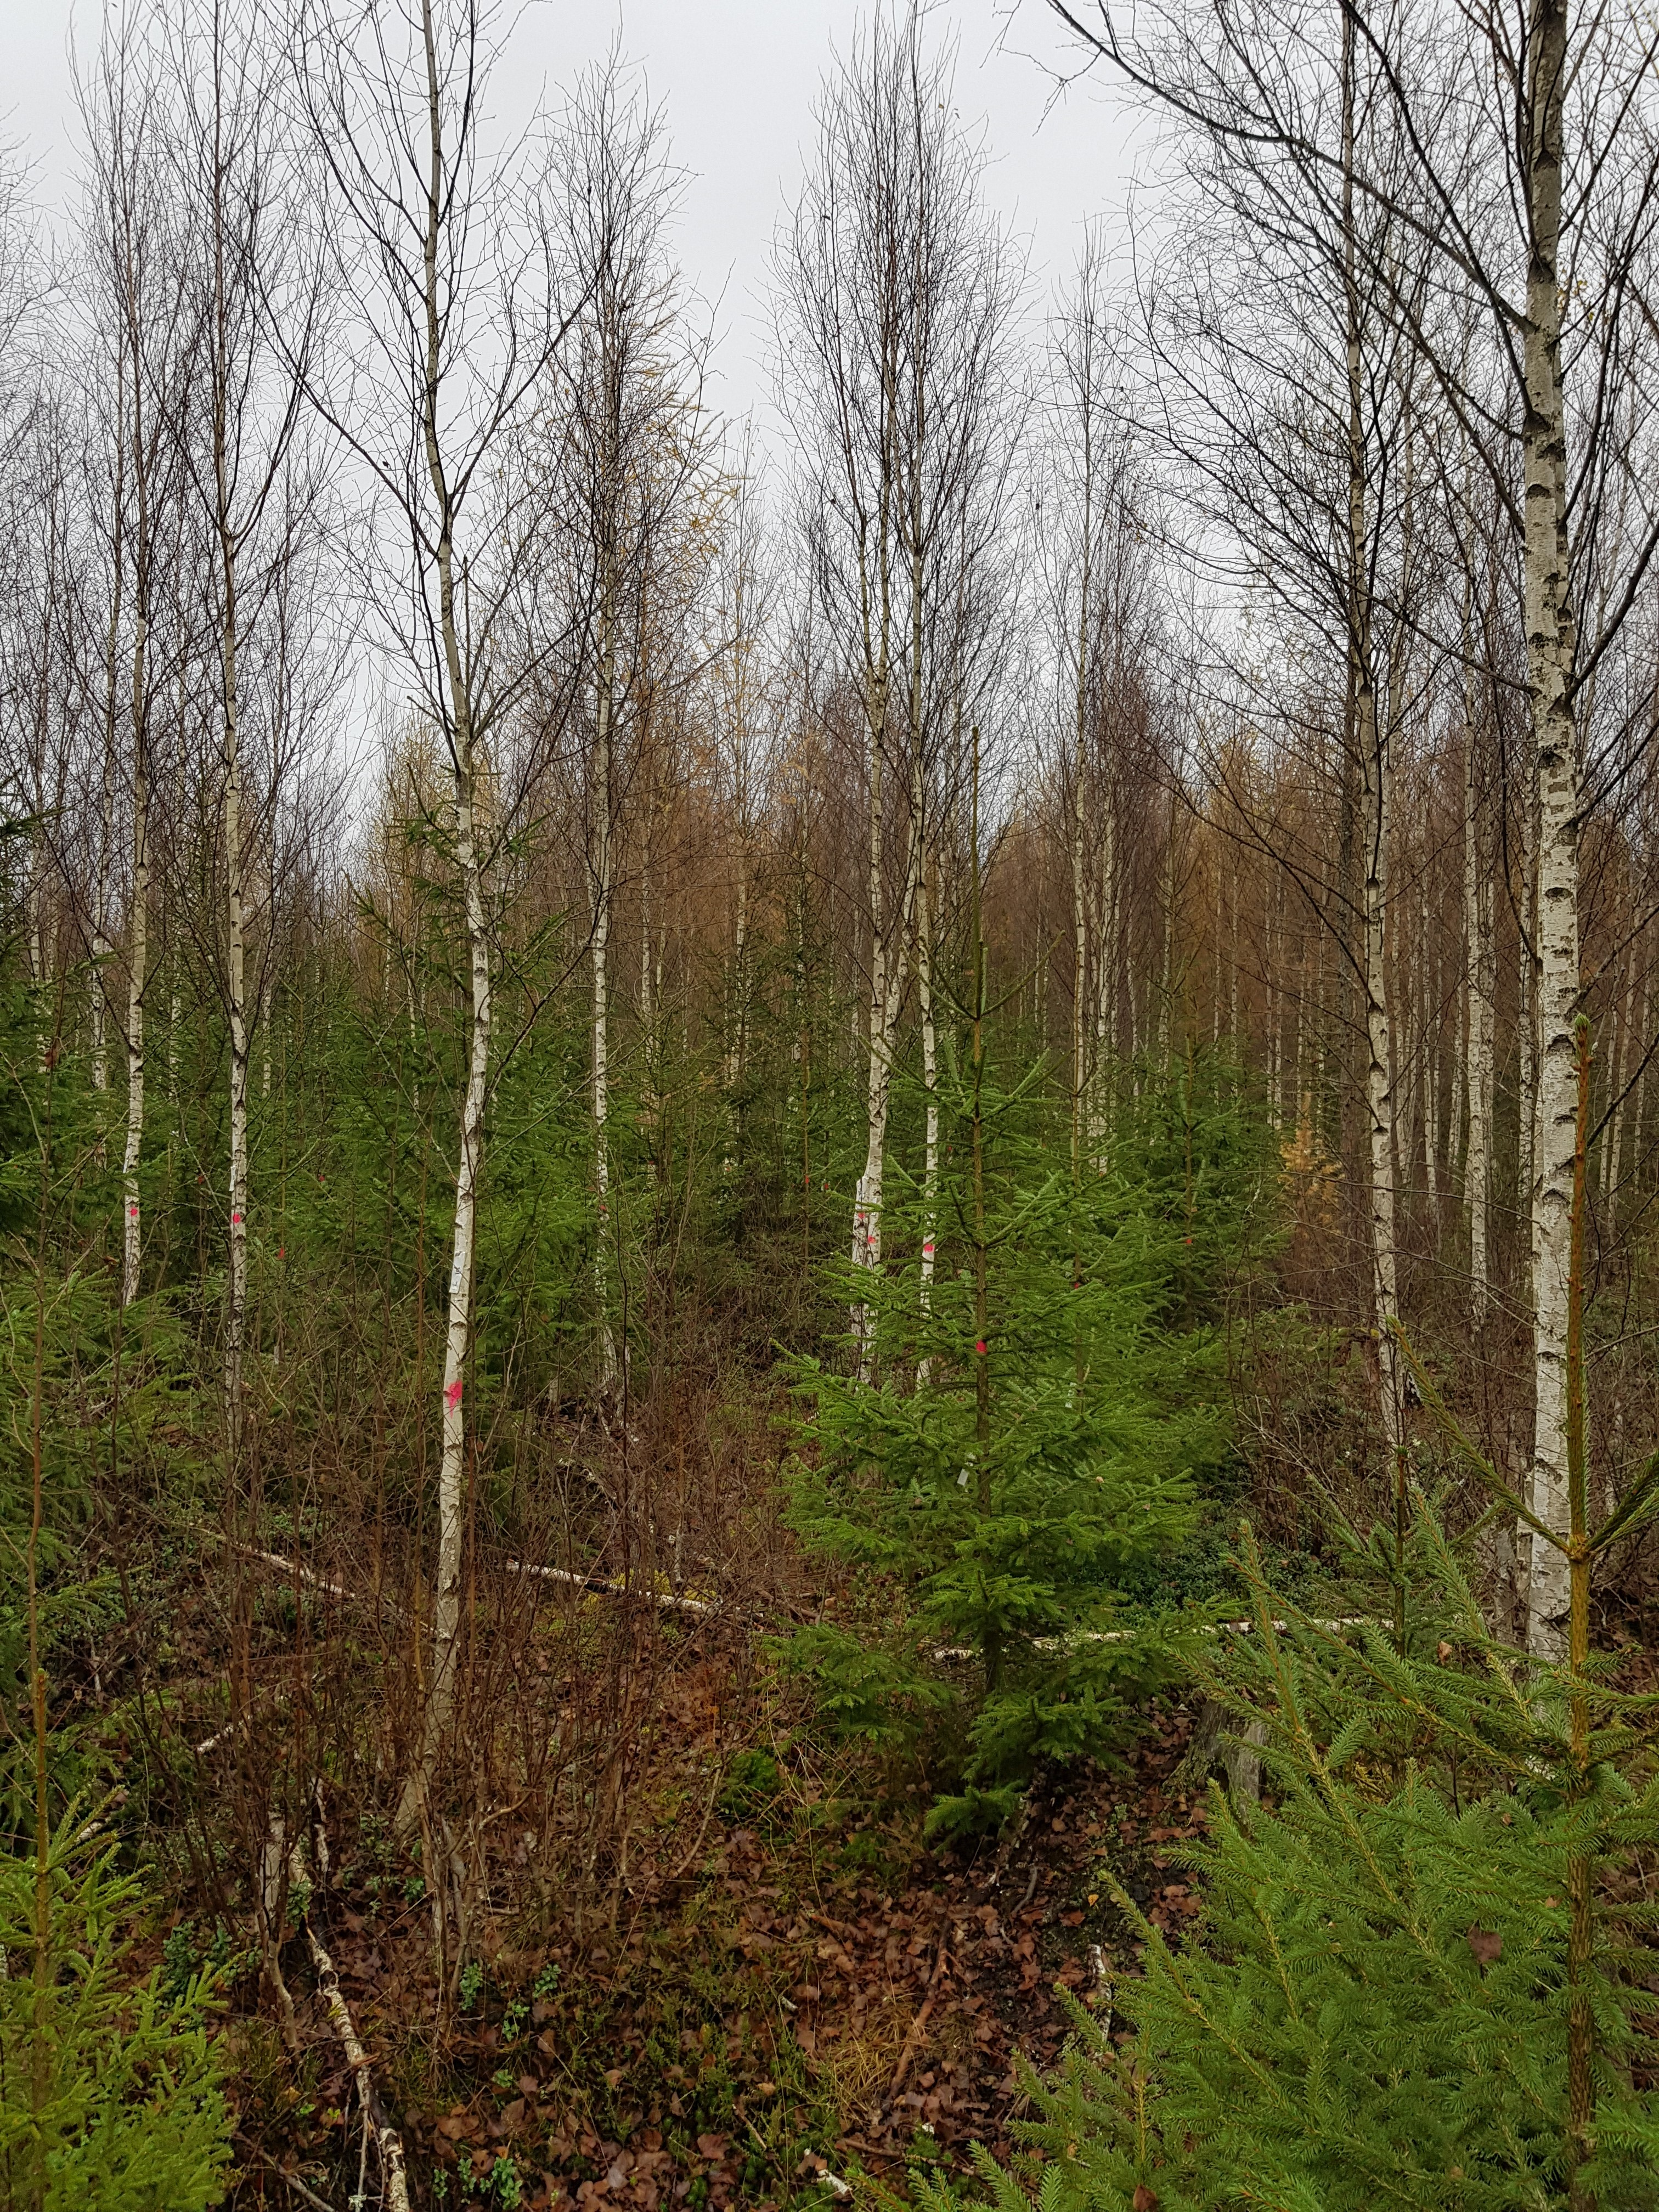

**Buffer zones, Cultural Heritage Sites, and Protected Areas**

Dense spruce undergrowth can be a problem common to buffer zones, protected areas and heritage sites. Low site impact may be imperative in such areas, and airborne systems could prove useful. If in or in the vicinity of inhabited areas or areas used for recreation, public access will, for safety reasons, have to be restricted when operations are in progress.

## Bioenergy

Harvesting of bioenergy is hardly an issue in thinnings. Should that change, it is unlikely that residuals can be extracted using drones. It may however be possible to remove whole trees, thereby potentially improving utilization of tree parts. Quantifying, or even confirming, this effect is not viable currently.

## Technical comments

When developing the harvester head, it is important that it can accommodate a harvester production data monitoring tool. This tool enables very precise and efficient follow up of operations, e.g. cutting rates. If combined with Lidar scanning, there is a wealth of information on the residual stand that can be extracted.

Fitting the drone with a grapple instead of a harvester head way be worth considering. In such a system the drone would be working with a light ground-based harvester operating from ghost trails, in the future possibly autonomous. That would make harvesting of broadleaves easier, enable harvesting of deformed trees, A grapple would further be lighter than a harvesting head, thus permitting bigger loads. With a ground-based harvester, the drone would further be transporting logs rather than stems with tops.

# 3. An operational evaluation of drones in thinning

Lars Eliasson

Most harvesting operations in the Nordic countries are made using ground-based harvesting techniques, mainly single grip harvesters and forwarders (Lundbäck et al. 2021). A small share of the wood in steeper terrain is harvested using motor-manual felling and processing and extraction with cable equipment or, on rare occasions, helicopters. In countries with a larger share of steep terrain cable and helicopter systems are used more frequently (MacDonald 1999). Due to the high costs of these extraction methods, they are mostly used for harvesting large trees either in final felling or selection cutting (MacDonald 1999) and care is taken to optimise load weight per turn to avoid loss in productivity.

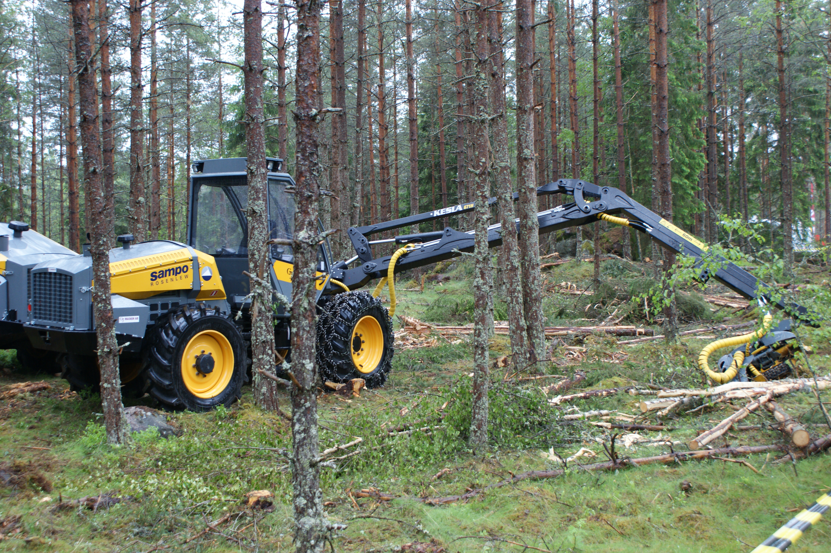Figure 3.1. Harvester in thinning of pine forest.

In thinning, harvester (Figure 3.1.) and forwarder productivity is low compared to final felling, leading to high costs (Eliasson 2022), and there are risks for damage to both soil and residual stand. One of the major causes of low productivity and, thus, high costs are that the trees harvested are small (Lageson 1996; Laitila 2012). To increase productivity in early thinning, technology and methods that enable multi-tree handling has been introduced. Operators try to minimise soil damage by avoiding sensitive areas and reinforcing strip roads with branches and tops of the harvested trees (Mohtashami 2022). However, as long as it is necessary for the forwarder pass the same strip road with multiple loads there is a risk for damage. Cable or air borne systems have the possibility to reduce or eliminate the risk for soil damage (Han and Kellogg 2000), but this comes at a higher harvesting cost. In selection harvest on flat ground harvesting costs of ca. 80 EUR per cubic metre over bark has been reported for cable logging methods (Schweier et al. 2023). Helicopters logging has high hourly operating costs (3000-4000 USD) and although the productivity can be high (>60 m3 per hour) when handling large trees costs per cubic metre is unacceptably high for Nordic conditions. Furthermore, helicopters are sensitive to tree size, load size, horizontal and vertical distance as well as weather conditions (Stampfer et al. 2002; Bigsby and Ling 2013). The performance of aerial drones that conducts early thinning has earlier been modelled in a master thesis, and the results were disappointing as the small trees harvested led to a costly extraction (Häggström and Svangärd 2022).

The aim of the present chapter of this study is to establish what revenues a drone for early thinning could expect to bring to the owner of the machine, given that the contractor is paid the current Swedish thinning prices per cubic meter solid under bark (m3fub).

## Material and method

Thinning using an aerial drone for felling, delimbing and primary extraction of single trees was simulated using ExtendSim. The efficient work time of the drone was modelled as the sum of the times for:

* Flight from the landing to the tree
* Positioning of the harvester head, delimbing the tree and felling
* Flight from the stump back to the landing with the felled tree
* Positioning of the stem in a stack on the roadside landing

The aerial drone is not assumed to cut the stem into logs. This work task is assigned either to the log truck, which can do it with a grapple saw, or to a central processing station at the receiving pulp mill. This assumption results in a limitation of the number of log products produced to two or three pulpwood assortments.

As very little data regarding the drone capacity was available at the time of the simulations four scenarios were analysed based on the following assumptions:

* The aerial drone can safely handle stems with a weight of up to 150 kg
* The unloaded drone can fly with a speed of either 6 (normal scenario) or 15 m/s (fast scenario)
* The loaded drone flies with an average speed that is calculated as $$\left(0.95-0.45×\frac{Stem weight}{100}\right)×Unloadedspeed$$
* In the normal positioning scenario positioning the harvester head takes 15s, including the time for identifying the tree top and get the head in the correct position. In the rapid-positioning scenario this time is reduced to 7.5 s.
* The time for delimbing and felling of the tree is dependent on tree volume and set to 3.3 s plus the time needed by a medium harvester to fell and process a tree of the same size.
* The distance from landing to the 0;0 coordinate in the type stand is set to 160 m The further distance to the coordinates of the trees harvested is calculated using trigonometry, on average this results in an extraction distance of 186m.
* To avoid unnecessary low productivity, trees with a commercial volume of less than 0.025 m3 under bark (u.b.) is not harvested.

This gives the scenarios:

1. Normal scenario. Flight speed (empty) 6m/s and 15s for positioning
2. Normal speed + rapid positioning (7.5s)
3. Fast scenario. Flight speed (empty) 15m/s and 15s for positioning
4. Fast and rapid scenario. Fast speed (15 m/s) with rapid positioning (7.5s)

As it is difficult to estimate the aerial drones cost per effective hour and its reliability no harvesting costs per m3u.b. is calculated. Instead, the drones potential gross earning per effective hour has been calculated as its productivity multiplied by the thinning cost for a conventional harvester forwarder thinning team under the same circumstances. The thinning costs has been collected from “Cost and revenues in Swedish forest 2021” (Eliasson 2022) and corrected to extraction of the same extracted mean stem size as in the simulated type stands.

In the late 1960s a large number of 0.1 ha (25x40 m) “Type stands” for thinning were collected by Royal college of Forestry (Bredberg 1972). In these type stands, every tree was positioned, measured (e.g. dbh, height, volume, weight, stem weight) and classified in a seven-grade scale based on the need to remove it in the thinning. Future crop trees for the final felling stands were assigned a 6 or a 7, and those with a lower rank were prioritized for thinning.

In the simulations three of these stands has been thinned with the drone (Table 3.1). The extraction rate has either been according to the standard instruction “Gallringsmall” ([Skogskunskap 2016)](https://www.skogskunskap.se/rakna-med-verktyg/skogsvard/gallringsmall/) or 35% of the standing volume (Table 3.2). Trees have been selected for felling from trees in thinning priority classes 1 to 5, starting from class 1 until enough trees has been selected to reach the desired extraction rate. Trees too heavy for the simulated drone or too small were excluded from selection. In stand 404, it was not feasible to reach a 35% extraction rate due to the large variation in tree sizes in the stand.

Table 3.1. Site descriptions

|  |  |  |  |  |  |  |  |  |
| --- | --- | --- | --- | --- | --- | --- | --- | --- |
| Stand | Age | Dominant height (dm) | Site Index | Dbh  (cm) | Basal area (m2) | Stems per ha | Standing volume (m3/ha) | Average tree volume  (m3ub) |
| 202 | 37 | 135 | T18 | 12 | 21.4 | 1780 | 126 | 0.060 |
| 208 | 38 | 160 | T22 | 14 | 25.0 | 1480 | 164 | 0.094 |
| 404 | 40 | 200 | G26 | 14 | 27.6 | 1500 | 231 | 0.131 |

Table 3.2. Extraction rates and extracted volumes in the scenarios with extraction according to gallringsmall and of 35% of volume

|  |  |  |  |  |
| --- | --- | --- | --- | --- |
| Stand | Extraction rate (% basal area) | Extracted volume (m3ub/ha) | Notes | 35% extraction rate  Extracted volume (m3ub/ha) |
| 202 | 27 | 28 | Average according to standard | 37 |
| 208 | 33 | 45 | Average according to standard | 49 |
| 404 | 14 | 28 | Low extraxtion to lower field in the standard. Thinning could have been postphoned | 69 (Not possible with the drone due to the set restrictions) |

## Results

In the scenario with 35% extraction rate, a fast drone with a rapid positioning the aerial drone reached a potential gross earning of 940 SEK per effective work hour in stand 208 (Figure 3.2). When the extraction rate is according to the standard instructions this is reduced somewhat, as the average tree volume is lower than in the 35% extraction rate case. In the combination of normal speed and normal positioning time, the gross earnings are reduced to between 400 and 500 SEK per effective hour. However, the drone is sensitive to transport distance from stump to landing (Figure 3.3), and with increasing distance the potential gross earnings are reduced. For the normal speed scenarios the predicted gross income before cost would be reduced by 20-25% by an additional 100 m in transport distance, i.e. an increase from 186 m to 286 m. In the scenarios with the fast drone an additional transport distance of 100 m would reduce predicted gross income by 17-23 %. Figure 3.3 also show large positive effects on time consumption of flying the drone with optimum load weights, 110- 140 kg in the case of the simulated drone. This is in line with previous experiences of helicopter logging (Dykstra et al 1978).

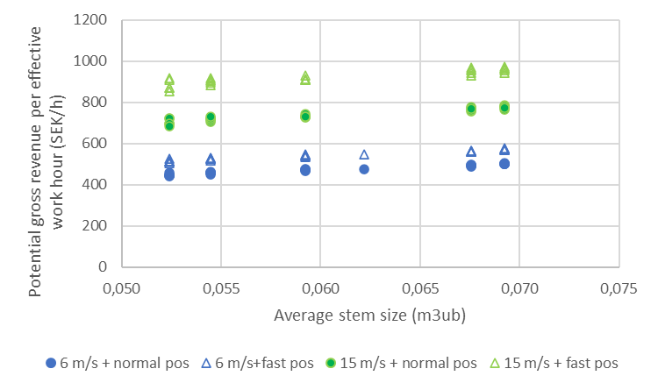

Figure 3.2. Potential gross revenue per effective work hour for the aerial drone in three forest stands. The four scenarios are based on the set of drone capabilities outlined in the materials.

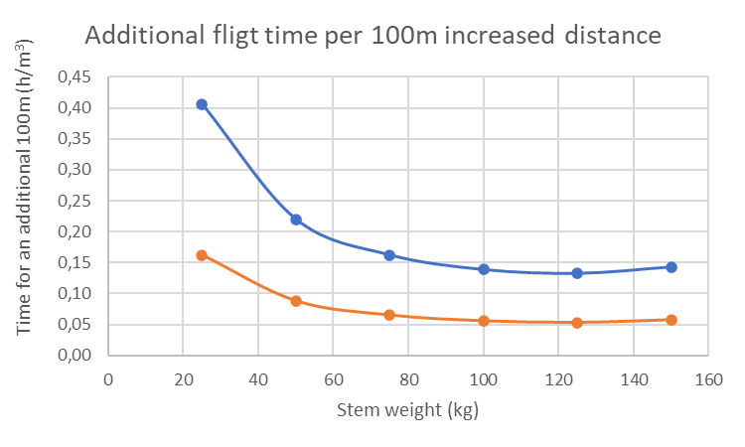

Figure 3.3. Additional flight time per 100 m increased distance between the tree and the landing. Blue line normal speed scenarios, orange line fast speed scenarios.

The gross earning per workplace hour will be far lower, as the time for establishment on a site, battery changes, repair and maintenance, and delay time due to bad weather has to be added to the effective work time. If one assumes that this additional time on average is 1/3rd of the workplace time, then the gross earning per workplace hour will be from 625 SEK in the fast drone with a rapid positioning case to around 300 SEK in the of normal speed and normal positioning time case. Given that the cost of a machine operator is roughly 400 SEK per workplace hour, a drone operator must be able to operate multiple drones in order to enable profitable operations for the drone owner.

Three other conclusions can be extracted from the simulations:

* Drone productivity is sensitive to the tree weight, an optimum load volume is close to the maximum payload.
* Small trees give low productivity. Small trees positioned close to larger future crop trees might be hard to position the harvester head on in reality which will cause further reductions in productivity.
* The desired extraction rates will be difficult to reach in thinning stands with a large variation in tree sizes, especially when the average stem weight is close to the safe cargo weight.

The fact that the simulated drone cannot handle large trees in a safe manner and that small trees have to be left unfelled, due to high costs, will lead to a thinned forest with a larger variety of tree sizes than after conventional thinning. The spatial heterogeneity of these stands will be higher as well as shown in the example in Figure 3.4.

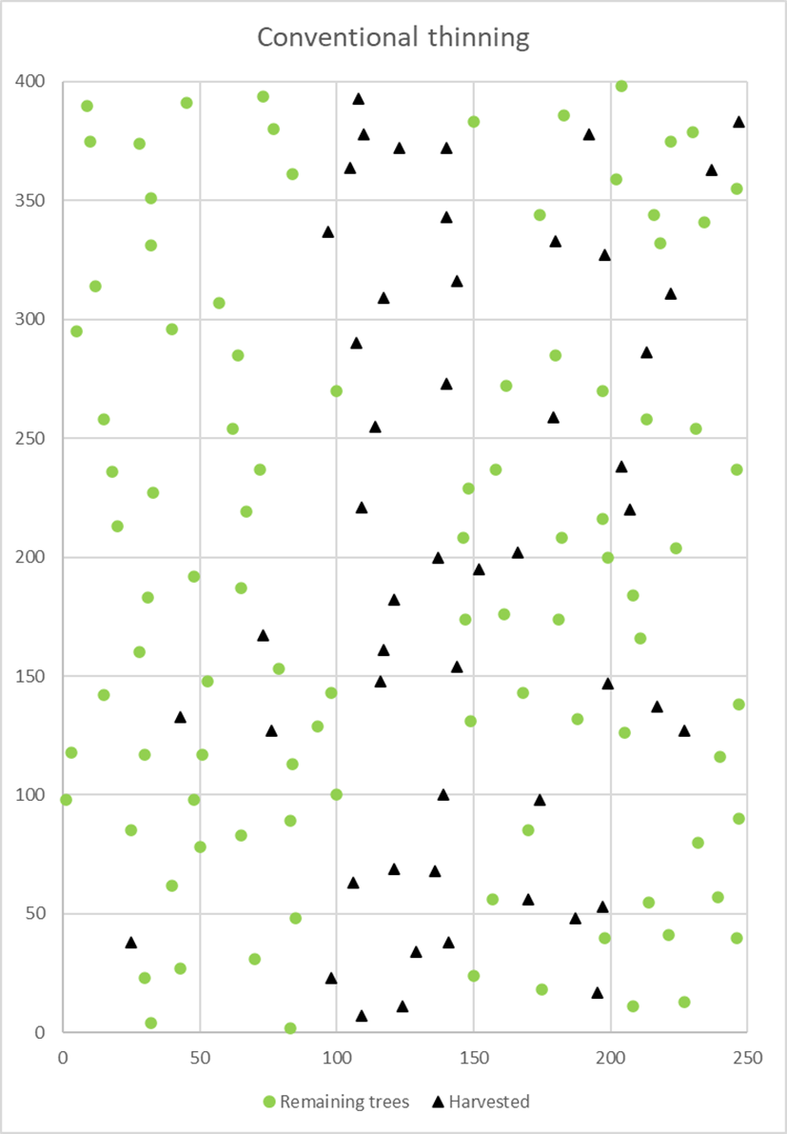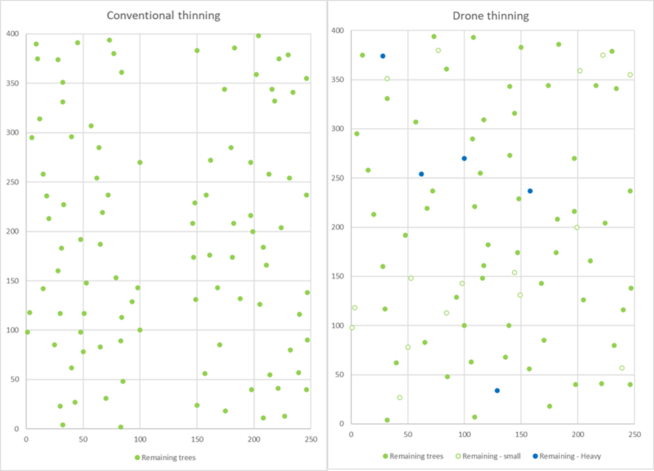

Figure 3.4. Stand prior to harvesting (top), residual trees after conventional thinning (bottom left) and thinning with a drone (bottom right). Harvested trees (Black triangles), Remaining trees (green dots), remaining due to small size (green circles), and remaining due to weight (blue dots). Thinning according to standard instruction (gallringsmall).

## Discussion

The results from the scenario “normal speed and normal positioning time” shows, as did the study by Häggström and Svangärd (2022), that a single aerial drone, under the assumptions made, is not an economically viable option for thinning. If it is possible to produce a faster drone with short positioning times the results get more positive in pure coniferous stands, but the profitability is still doubtful. However, as the system is sensitive to increased transport distances, even a faster drone will not be a solution at long distances. A cost not taken into account in the analysis is the cost for cross-cutting the stems into logs at the landing. This cost can be kept low if done by a grapple saw on the log truck, but that may reduce the value recovery for possible saw logs. One thing that will improve the cost efficiency of drone operations is if some work tasks can be automated, allowing one operator to operate two or more drones at the same time. The total economy of the system is also dependent on the investment cost which is not known today.

If, as in central Europe (Schweier et al. 2023), minimum impact operations get government subsidies or if landowners are prepared to pay more for the thinning service than the current market price the results will be more positive for a drone contractor.

It is hard to see how an airborne drone system becomes an option for deciduous or damaged trees as it depends on a harvester head that delimbs the trees from the top and down. Crooked, multi-topped or damaged trees may pose a challenge for such a harvester head.

Like helicopters, aerial drones will be sensitive to adverse weather conditions and vertical distance which has not been taken into account in the calculations. Furthermore, powerlines, trafficked roads and populated areas will restrict where it will be possible to operate air borne equipment. Separate analyses of the expected effects of weather on the effective work time, and of the effects of areal restrictions on the area possible to thin with airborne equipment are necessary for accurate estimations of the feasibility of thinning using aerial drones.

One thing that would optimize the extraction performance is if the drone could work with an optimized load weight for each trip between the forest and the landing. Maximising pay loads are one of the most important factors affecting productivity in helicopter extraction of logs (Conway 1982; MacDonald 1999). However, as the drone is designed to delimb, fell and extract the trees, achieving optimum pay loads will be difficult given the thinning instructions. One option could be to have a two-machine system, where a second machine fells the trees, delimbs and cut them into logs piled into weight-optimized piles to improve aerial drone productivity (cf. Dykstra et al 1978). Thereafter, the aerial drone extracts these weight-optimized piles of logs to the landing. The use of a ground-based machine for the felling and processing part would also solve many of the issues associated with to heavy trees and removes the problems with having to delimb deciduous or damaged trees from the top down. Furthermore, it has the advantage that an optimal mix of log products can be produced, as in the current harvester and forwarder system. Today, felling and processing could be done by a small thinning harvester, but in the future it might be more realistic with a small ground-based drone cooperating with the aerial drone.

# 4. Airborne drones in forestry from a biodiversity standpoint

Emelie Fredriksson & Line Djupström

## Background

Forest management in Sweden is almost entirely based on rotations of 70 to 100 years. It is common for stands to be treated with pre-commercial thinning followed by one or two thinnings, which have well-documented impacts on biodiversity, both at the local and landscape scales (Esseen et al. 1997). Thinning is, in terms of area, the most common harvesting operation, with approximately 40 percent of Swedish forests in the thinning phase, usually around 30 years old. The thinning phase of the rotation is the phase that has the lowest amount of coarse woody debris (Ranius et al., 2003), a structural component of high importance for biodiversity (Stenbacka et al. 2010, Peltoniemi et al. 2013) and one that is currently in short supply in the modern forest landscape (Siitonen et al. 2021, Fridman et al. 2000). Current forestry standards for thinning operations encompass guidelines aimed at both creating and protecting structures that hold biodiversity value, including creating high-cut stumps (Figure 4.1), and protection of old trees (Albrektson et al. 2012). The thinning stage specifically has enormous potential to add dead wood since its lacking at a landscape level and beneficial to many species, such as beetles (Thibault et al. 2016, Lindbladh & Abrahamsson 2008). However, issues such as soil compaction, tree damage, and rutting are often challenging to mitigate when heavy machinery is used in the forest (Worrell & Hampson, 1997, Sirén et al. 2013). These issues can have significant impacts on ecosystem functioning and important structural components. In this section, we aim to evaluate the potential differences between conventional thinning systems and airborne systems in terms of their biodiversity impacts at a theoretical level.

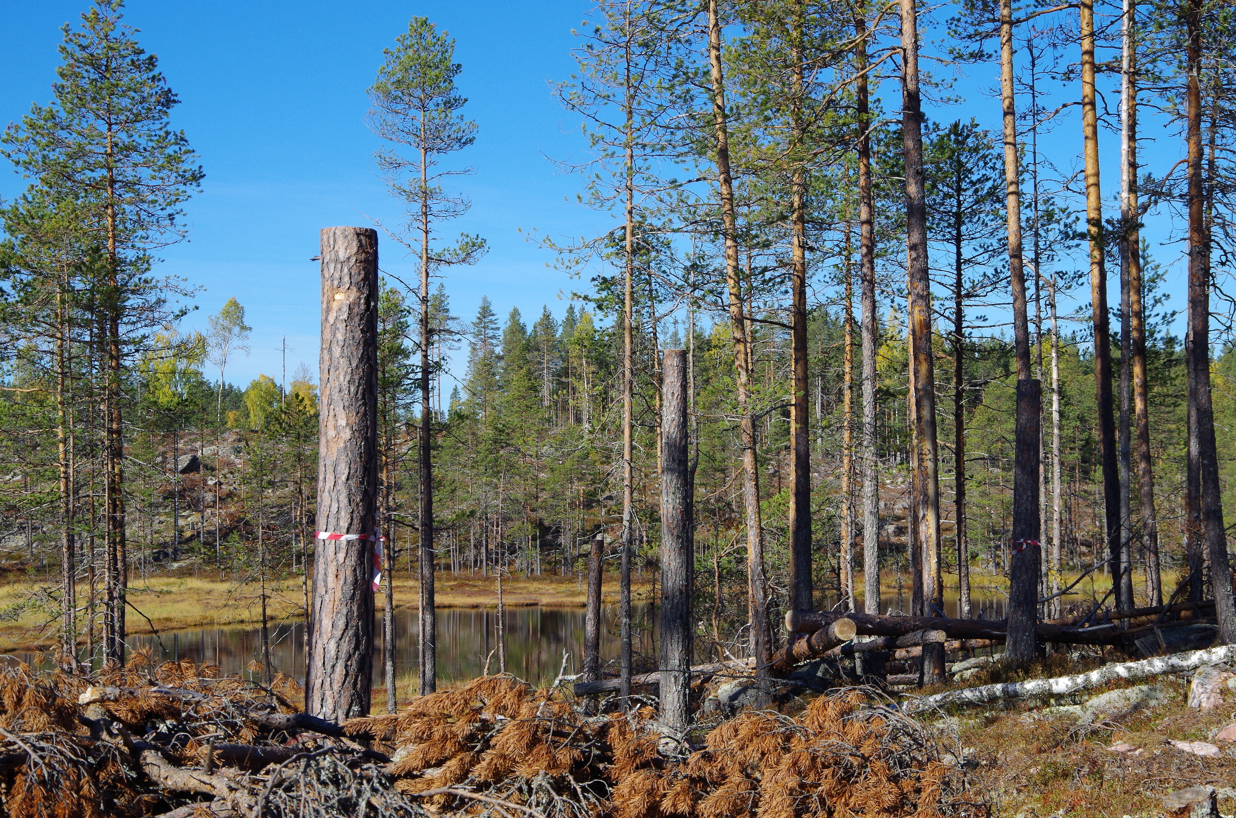

Figure 4.1. High-cut stumps are a common Swedish conservation measure aimed at cutting trees at a height of 3-4 meters, thus creating standing, sunexposed deadwood. High-cut stumps are long-lasting substrates that provide habitats for extended periods *(Credits: L. Djupström).*

## Method

To evaluate and describe the potential impacts on biodiversity when thinning with an airborne system compared to a conventional thinning system using a ground based harvester and a forwarder, we conducted a literature review. To our knowledge, no direct effects of airborne systems on biodiversity have been studied, even from historical attempts to harvest from the air using helicopters or balloons. Thus, we focused on theoretical possibilities and the positive/negative effects that will arise when thinning not using conventional methods is done such as potential reduction in soil compaction.

The literature was gathered using the search engine Google Scholar with keywords related to forest thinning impacts on different types of biodiversity and the environment. This review was not conducted systematically, where a specific search string was used, and all results were evaluated. Instead, our goal was to gain an overview of the literature regarding the impacts of thinning using conventional methods, providing examples across a wide range of taxa and emphasizing relevance to Sweden.

## Results

### Strip roads and soil impact

Thinning with drones is anticipated to yield positive environmental outcomes, primarily attributed to the elimination of strip roads. During mechanized logging operations, temporary logging roads (strip roads) that are typically 4-4,5 meters wide are created. Even though strip roads are a temporary measure, they still impact the functioning of the forest ecosystem and alter local conditions in various ways. These strip roads change the structure and create a linear feature in the otherwise intact forest canopy, but mostly the driving of heavy machinery can lead to soil compaction, altering the soil structure and reducing its ability to absorb water, thus impacting water filtration and erosion (Worrell & Hampson, 1997; Nikooy et al. 2020). Compaction can also increase surface runoff and nutrient leakage affecting aquatic ecosystems (Worrell & Hampson, 1997).

The establishment and use of strip roads can result in direct damage to the trees' roots, and in turn, increase the risk of root rot (Wästerlund 2020). Heavy machinery may destroy dead wood in the late successional stages that already exist in the stand. Heavily decayed coarse dead wood, both standing and lying down (logs), is rare in Fennoscandia today and is an important structure to preserve for both insects (Siitonen 2001) and polypores (Sippola et al. 2001). This also holds true for species that are sensitive to disturbances in general. Canopy gaps, inevitably formed by strip roads, can also positively impact biodiversity. For instance, these openings can mimic natural small-scale disturbances, leading to higher diversity of saproxylic insects in stands with sun-exposed dead wood in strip roads (Joelsson 2017). These gaps can play a significant role in establishment of early successional species in several ways. Increased light availability on forest floor promotes light-demanding plant species with positive impacts on plant diversity and richness compared to non-thinned stands (Strengbom et al. 2018, Widenfalk & Weslien 2009). Increased sunlight warms the forest soil which can activate seed bank and accelerate seed germination and enhance plant growth and establishment of new plants. When trees are removed competition is reduced and nutrients become available and early successional species can capitalize on this nutrient influx and allowing them to establish.

Using an airborne harvester could potentially mitigate some of the negative impacts discussed above that are directly linked to strip roads, especially those affecting the forest soil ecosystem. Harvesting with a drone would also provide greater flexibility to adapt the harvesting process to achieve stand-specific goals aligned with promoting biodiversity and ecosystem functioning. The adaptation could be to choose trees to harvest or leave that has a positive effect on structure and spatial distribution that may promote biodiversity.

Understory vegetation cover

Since no machines are needed on the forest floor when using drones there will be no need to make strip roads (discussed above) and/or removal of field layer trees or scrubs. Removal of smaller trees and scrubs is common in conventional thinning operations in Swedish forestry today (sight clearing or, in Swedish,“förröjning”, Albrektson et al. 2012) to increase visibility for machine drivers and enhance chainsaw cutting. Removal of understory vegetation reduces the vertical variation in the stand which has been shown to be important for both birds and pendulous lichens (Klein 2020). From a biodiversity perspective the ability to keep a dense understory layer when thinning with a drone could be positive also for species that require shelter from predators. The vegetation also acts as an important forage resource for ungulates.

Invasive species

A machine driving over the ground can entail an increased risk of spreading invasive plants, among other things, as seeds and other matter may be carried into the forest from one location to another through the tires (Rauschert et al., 2017). That risk should be minimal with drones.

Environmental pollution from noise propagation

Wood harvesting, including forwarding operations, can be achieved by different systems depending on the site terrain characteristics. Nevertheless, the operations commonly use mechanized equipment that produces noise and generates vibrations, which may have a negative effect on sensitive wildlife. Noises creates disturbances and can stress animals, interfere with their communication, behaviors, and drive them away from important areas (e.g., Kight & Swaddle 2011). The impulsive noise propagation generated from chainsaw is well recognized as being one of the most significant noise sources in forest operations even when compared to helicopters, noise based on the example of reaction of owl (Delaney et al. 1999). The effects of aerial activity from small drones and other free-flight (hand-gliders, paragliders and powered derivatives) on wildlife has been reviewed by Mulero-Pázmány et al. (2017) and Tobajas et al. (2021). Mulero-Pázmány et al. (2017) found that birds are more prone to react than other taxa and larger birds more than smaller birds. Tobajas et al. (2021) indicates that unrestricted flying activities disturb wildlife animals of ungulate species and species of raptors by causing adverse impacts such as heightened energy consumption, decreased feeding duration, abandonment of feeding zones, diminished breeding success, deterioration of physical condition, heightened risk of predation, and potential harm from flight-related accidents. Nevertheless, the inadequate research on various species and locations, coupled with the limited number of long-term studies, hinders a comprehensive evaluation of the present status concerning the influence of this activity on wildlife.

Along with the potential disturbance from the presence of flying drones in forests, aerial harvesting methods still necessitate the use of an electric chainsaw on the harvester head. However, the noise levels from such a saw are lower than the petrol-powered saws used in motor manual felling. However, disparities from ground-based thinning, encompassing variations in sound levels and operation duration, mandate thorough monitoring and analysis of the specific area. Only after such an assessment can any informed conclusions be drawn regarding potential environmental impact.

Theoretical potential and uncertainties

We envision the potential for goal-oriented forest management that is flexible and less spatially constrained when conducting thinning operations with a drone, as opposed to using a conventional harvester. This approach allows for extra consideration of buffer zones along waterways, selective clearing of important broadleaves such as oaks, and deliberate creation of dead wood that are above the current requirements from example FSC (Forest Stewardship Council 2015). Creation of high-cut stumps and conservation of natural structures and processes in stands have been seen to be of high value for biodiversity, especially in mid-rotation stands where diversity was found to be generally low (Peltoniemi et al. 2013). There is also a significant opportunity to create gaps of varying sizes, depending on local conditions, to emulate small-scale natural disturbances, thus positively impacting species that thrive in disturbed environments. For example, creating a mosaic of forest patches with different densities of trees through thinning has been seen to be positive for bats in Canada (Patriquin & Barclay 2003). Depending on the drone's range, there is also potential for implementing smaller nature conservation measures outside the actively thinned stand. However, to fully realize these potential benefits, effective tools for planning and the identification of structures, such as old broadleaf trees, from the air are necessary. There may be a negative impact from the fact that areas that have not been accessible with traditional forestry machinery, for example, technical impediments, which may now be harvested with the increased accessibility provided by drones. These areas often have high environmental values because they have been left undisturbed and frequently host a wide variety of habitats due to the for example diverse topography. It is always important to assess the value and the need for consideration before tree harvesting takes place.

Concerning the construction and methodology employed by an airborne system, it executes a sequence that involves clearing a tree's branches during its descent, followed by precision cutting and lifting of the entire tree, including the top, from the forest floor. This process results in the creation of a 'bouquet' composed of small branches encircling the stump of the harvested tree. The tree top and branches, referred to as slash, represent a woody residue with valuable potential for bioenergy applications. This utilization is more commonly observed in final felling operations. In Sweden, it is customary to leave approximately 20% of the woody residue, encompassing treetops, in the forest (Skogsstyrelsen 2008). This practice is rooted in environmental considerations, as it contributes to the nutrient cycle and enhances the availability of deadwood. Adhering to Forest Stewardship Council (FSC) regulations, woody residues from broadleaf trees (excluding Betula spp.) are mandated to be retained, with treetops from all broadleaf trees falling under the same stipulation. It appears feasible that thinning with airborne systems could potentially leave treetops for conservation purposes.

Small-diameter deadwood can also hold significance for biodiversity of for example beetles (Brinn et al. 2011, Seibold et al. 2018) but not to the same degree as large diameter dead wood (Heilmann-Clausen & Christensen 2004), although it is not as rare as large-diameter deadwood. One needs also consider the impact of branches covering vegetation and especially lichen rich ground in northern Sweden, as it is a declining and important recourse for reindeers (Sandström et al. 2016). However, the specific impacts in this form of harvesting remains unknown until field studies can be conducted.

## Conclusion

In summary we conclude that thinning with an airborne system in comparison with conventional methods has potential to reduce negative effects, especially in terms of no direct damage on the soil, water, structures such as logs and cultural heritage. There might also be room for larger flexibility both spatially and temporally depending on local conditions and stands specific goals to harvest trees in different times of the year and in more difficult terrain (wet or steep). This unlocks possibilities to create and preserve structures of importance for biodiversity and to emulating small scale natural disturbances to a higher degree. However, the magnitude of these potential effects on biodiversity cannot be determined from a literature review but must be evaluated with field trials comparing the two harvesting methods and monitored over time.

# Effects on growth, stand development and stand economy – simulations in Heureka

Magnus Persson

## Background

There are technological differences between the AirForestry drone system and the conventional harvester/forwarder system which suggest differences in how the thinning operations could be carried out (harvesting method). Strip roads account for 15-20% of the thinning intensity using a conventional harvesting system, and typically an additional 10-15% is harvested to create more growing space for the remaining trees in-between the strip roads. The drone system does not demand establishment of strip roads at first thinning, which allows a freer selection of trees and potentially lower thinning intensity (see discussion about tree selection in previous chapters). Another main difference between the drone system and a conventional harvester/forwarder system is the freedom of movement. Potentially, the drone system will likely be working in groups and should be able to operate over larger distances from the landing area than the conventional harvester/forwarder system. Consequently, these two factors enable lower thinning intensities and that a stand can be thinned more frequently, given that forestry in the area is planned at the estate level and larger and that an equivalent volume must be harvested in thinning during the rotation.

## Objective

In this sub-project, the potential benefits of harvesting using Airforestrys’ drone system is compared to a conventional harvester-forwarder system. The primary objective is to determine if there are any potential benefits directly related to the harvesting technology excluding the influence of forest management goal.

## Materials

The stands used in the simulations represented young stands ready for early first thinning, i.e. at 12 meters in dominant height (Table 5.1.). The stands were created based on what is a mature thinning stand in the Swedish Forest Agency (Skogsstyrelsen) thinning guides (SKS 1984). The basal area coinciding with the upper limit in the thinning guideline at 12 m in dominant height for each site index (T22-T28, G26-G32) was used. Each stand was assumed to have a stem number of 2000 stems per hectare. The stands were assigned an average diameter, age, etc. via other forest models.

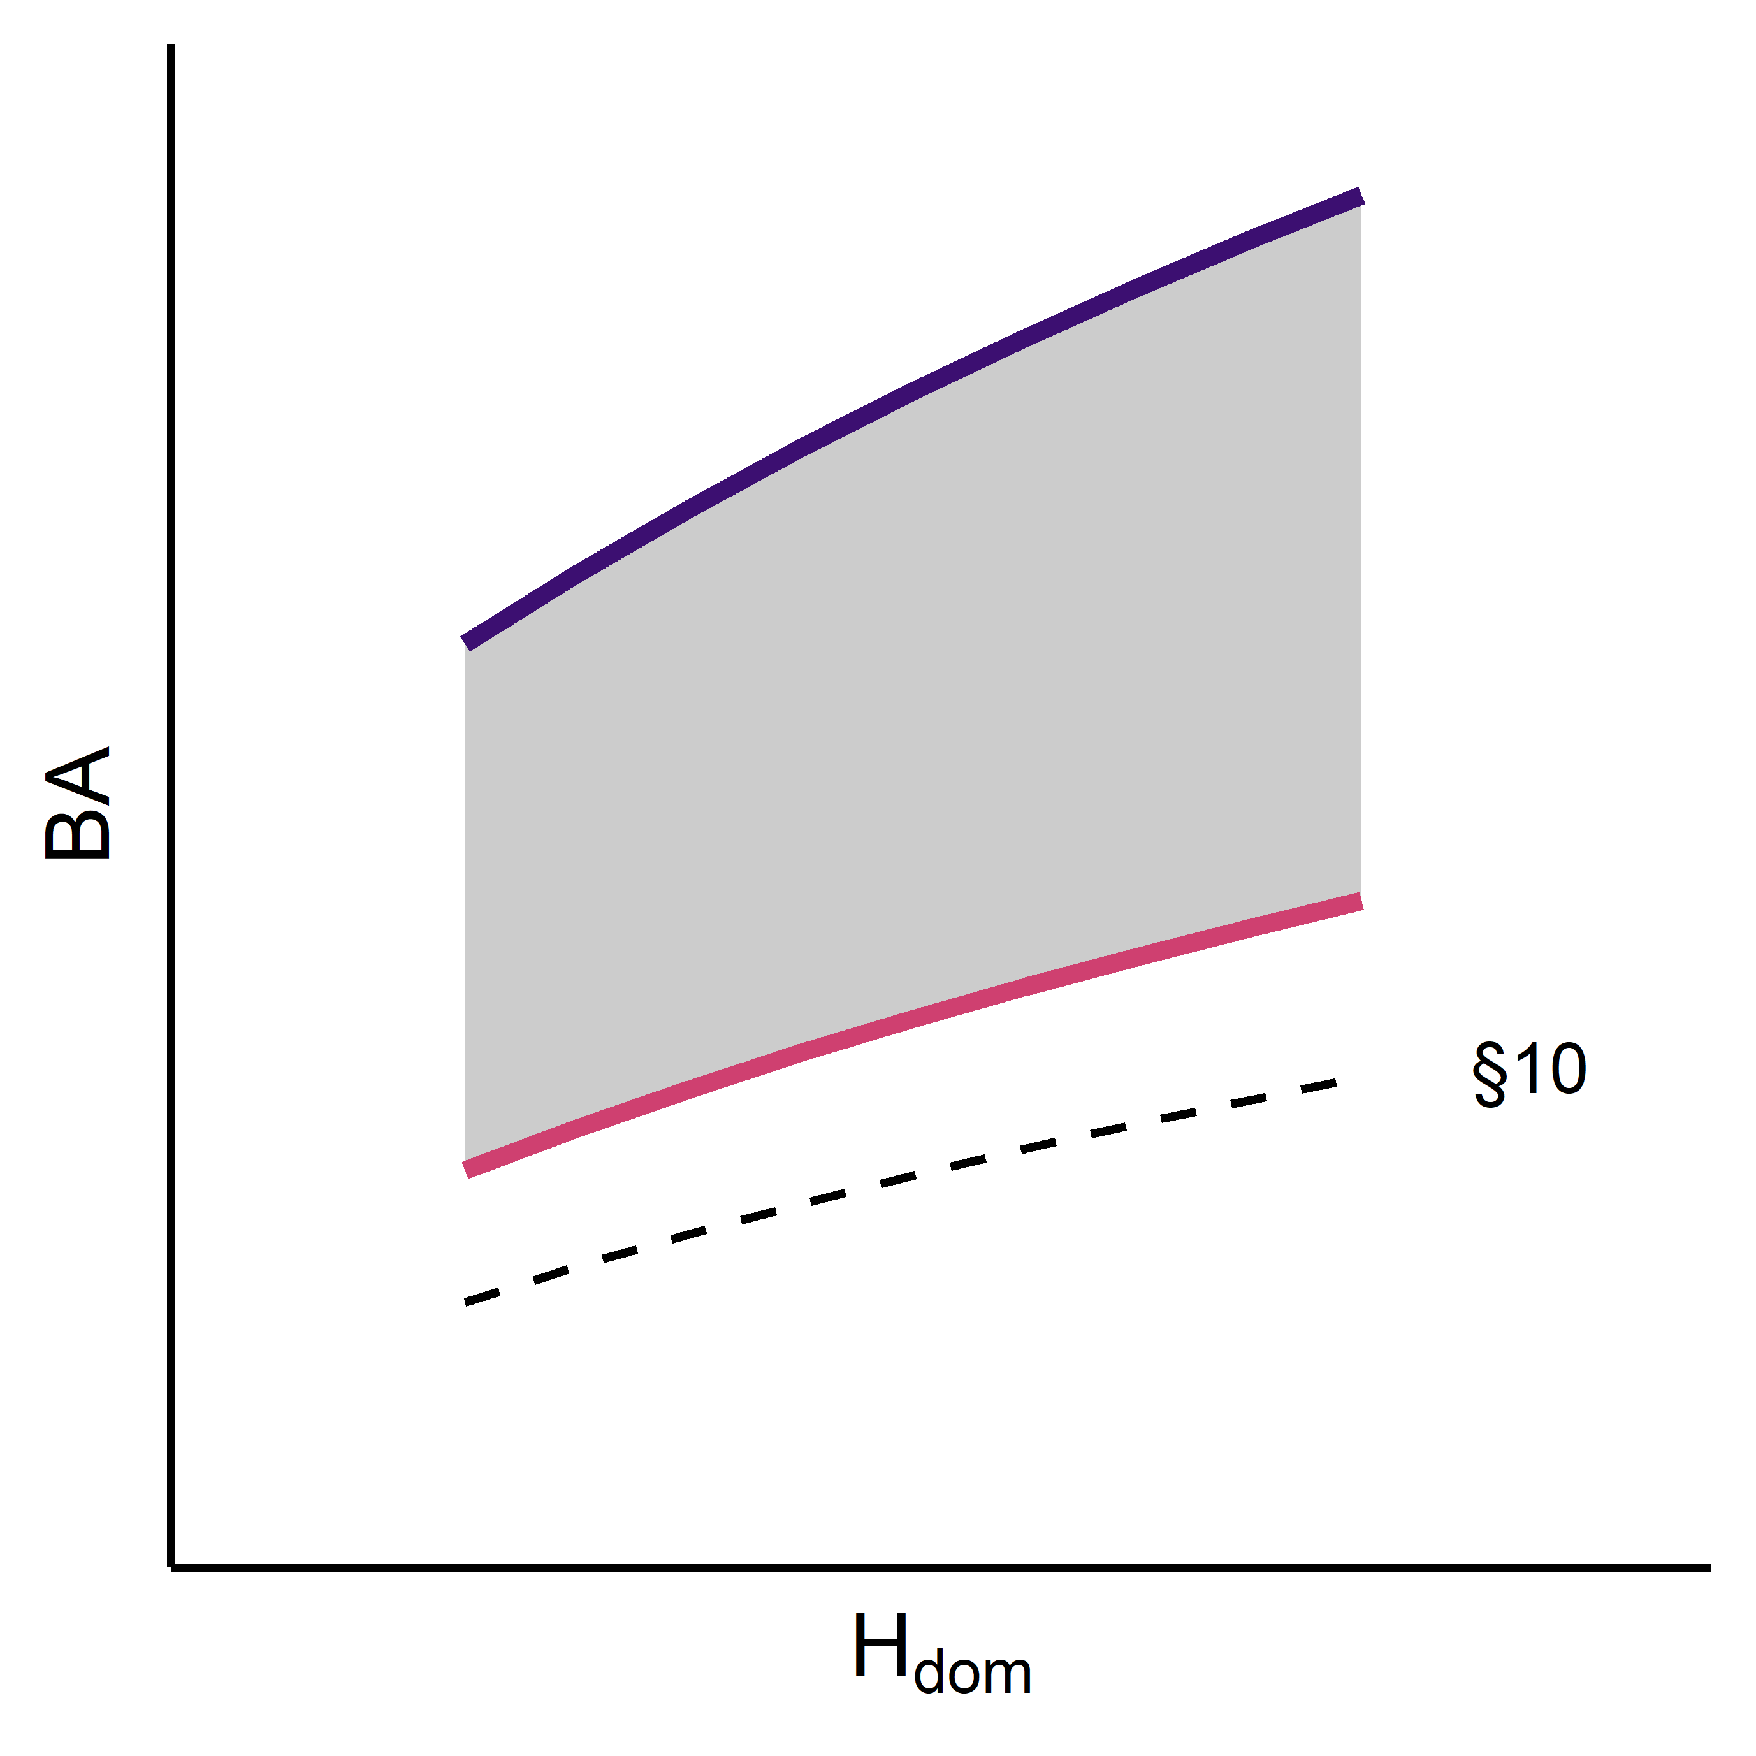

Figure 5.1. Thinning guide with basal area on the y-axis and Hdom on the x-axis, along with an upper target line (deep purple) and a lower target line (crimson red) representing the range in basal area. The dashed line represents §10 in the Forest act.

Table 5.1. Summary of the stands: their site index, stem number, basal area and DGV.

|  |  |  |  |  |
| --- | --- | --- | --- | --- |
| Tree species | Site index (H100) | Stem number | Basal area | DGV |
| Scots pine | T22 | 2000 | 21.3 | 12.7 |
| Scots pine | T24 | 2000 | 22.2 | 12.9 |
| Scots pine | T26 | 2000 | 23.2 | 13.2 |
| Scots pine | T28 | 2000 | 24.1 | 13.4 |
| Norway spruce | G26 | 2000 | 25 | 13.8 |
| Norway spruce | G28 | 2000 | 25.4 | 13.9 |
| Norway spruce | G30 | 2000 | 25.8 | 14 |
| Norway spruce | G32 | 2000 | 26.1 | 14.1 |
|  |  |  | N = | 8 |

## Method

### Assumptions

Given the assumptions above, moderate or heavy thinning can be avoided using the drone system. This could potentially lead to temporarily higher growth after thinning as stand production is largely determined by the basal area (m2 ha-1) after thinning (Ekö, 1985; Pienaar, 1979). During the whole thinning phase, these differences may speak in favor of more frequent and less intense thinning interventions.

The forest owner's management objective is summarized as being able to harvest approximately the same volumes during the thinning phase, which results in the forest looking roughly the same for the two different scenarios after the thinning phase is over. We also deemed it likely that forest managers and forest owning companies will not change the forest management goals only due to new harvesting technology. Based on the unchanged management objective and the potential differences in thinning methodology between conventional thinning and AirForestry’s drone system, it was assumed that the latter will conduct more frequent but less intense thinning as compared to fewer and heavier thinning with the conventional harvester/forwarder system. We also assumed that Airforestry’s drone system will be capable of conducting both first and later thinning, where the weight of the trees exceeds the current weight limit.

### Simulations

Simulation and optimization of management was made in the forest decision support system Heureka PlanWise (Lämås et al., 2023). The Heureka system contains all forest growth and yield models necessary for accurately forecasting the state of a given forest over time for Swedish conditions, implementing silvicultural treatments and accounting for the growth response. PlanWise is normally used for forest planning problems, such as dealing with silvicultural treatments on estate levels and using the optimization module to render optimal management regimes based on a set of management restrictions and the objective function, which normally is maximum net present value.

The stand defined from the thinning templates were imported as stands into Heureka PlanWise (Table 5.1.). From the stand attributes, individual trees were simulated, rendering a good material for further analysis. The simulated stands were used as a basis for evaluating the differences between the conventional harvester/forwarder system and Airforestry’s drone system. Two scenarios were constructed which relied on assumptions made based on how AirForestry is thought to operate differently than the conventional harvester/forwarder system and that both harvesting systems were used to reach the same management goal. However, the way to meet those goals differed due to the technological difference. By not setting the same forest management goal, the demanded output from the thinning operations would change, resulting in a comparison of silvicultural treatments which would have confounded the effects.

The technological differences between the systems were implemented by adjusting the silvicultural rules defined in Heureka. Most rules follow the default-settings, but some were changed to capture the proposed differences between the thinning technology/method of Conventional (CONV) and Drone (DRONE, Table 5.2.). Fixed costs are weaved into the variable costs in Heureka and they were assumed to be equal for the two systems as there is no data available for Airforestry.

Table 5.2. Diverging silvicultural rules for the two scenarios.

|  |  |  |
| --- | --- | --- |
|  | Conventional (CONV) | Drone (DRONE) |
| Max Number of thinnings | 2 | 4 |
| Min/Max Thinning grade | 25%-40% | 12-12% |
| Min Height Thinning | 11 | 11 |
| Max Height Thinning | 15 | 15 |
| Max Height Any Thinning | 20 | 20 |
| Thinning guide reduction upper | 0.90 | 0.80 |
| Harvest strip roads | Yes | No |

First, the optimal thinning program for CONV was carried out based on the silvicultural rules in Table 5.2. using a discount rate of 2.5%. Subsequently, the maximum and minimum thinning intensity for DRONE was tried out manually. The maximum thinning intensity was set to 12% for all site indexes and tree species for DRONE, as it produced the most similar stands after the thinning phase (20 m in dominant height). Harvest of strip roads was enabled for CONV which meant that tree selection in first thinning was limited in the zone in between the strip roads. For DRONE, strip roads were not used which meant freer tree selection. Strip roads only affect cost calculations in Heureka and do not affect production.

### Land Expectation Value

Normally, the net present value calculation in Heureka PlanWise is done by combining the net present value of the first-generation forest and the Land Expectation Value (LEV) for the subsequent generation. The problem with this is that the initial stand density relative to the thinning template is essential for our analysis and this is disregarded when the new generation of forest is simulated. In our case, the LEV-calculation was adjusted to account for the circumstances of the first generation. The net present value calculated separately for each management program by discounting the revenue to year 0, e.g. when the previous stand was final felled. The establishment costs prior to first thinning (20-40 years after stand establishment) were adapted from the reported Forestry costs (Eliasson, 2021). Planting was assumed to take place at year 0 and on pre-commercial thinning at year 3 and 10. LEV was derived by multiplying the calculated net present value from the first rotation with the with an eternity factor, representing that the management regime in the first rotation was repeated forever. The choice of optimal management program for each scenario was therefore based on this new calculation of the LEV.

### Result variables

The evaluation of the scenarios was done for a number of stand attributes that provide an understanding of how the different management scenarios affect different aspects of stand development (basal area, stem number, DGV, total carbon stock, standing volume) current annual increment and assortments (pulpwood and timber). All result variables were reported by stand index and tree species and are defined in the glossary in the Appendix.

## Results

### Thinning regime

The results show that approximately the same stands could be created during the thinning phase in terms of basal area (Figure 5.2.) stem number (Figure 5.3.), total carbon stock (Figure 5.4) and standing volume (Figure 5.5.) with both scenarios but with different paths to the target. The stands in each scenario developed similarly during the thinning phase for each studied stand attributes, however, the lowest levels were avoided in DRONE. The time of final felling was the same in most cases.

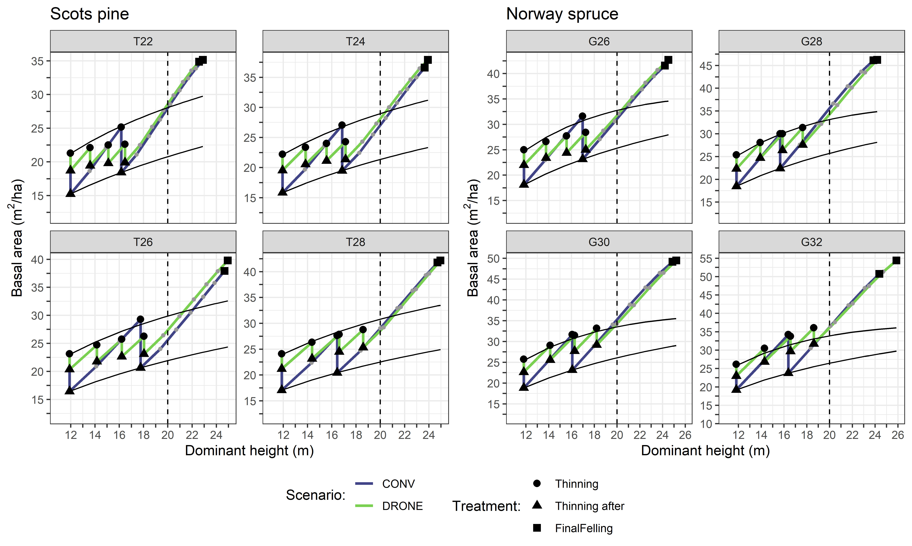

Figure 5.2. Basal area over dominant height for each site index and respective tree species.

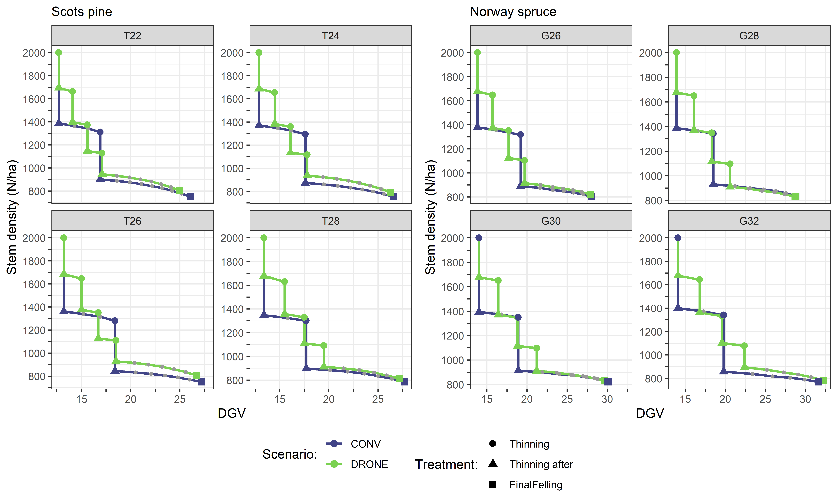

Figure 5.3. Stem number over DGV for each site index and respective tree species.

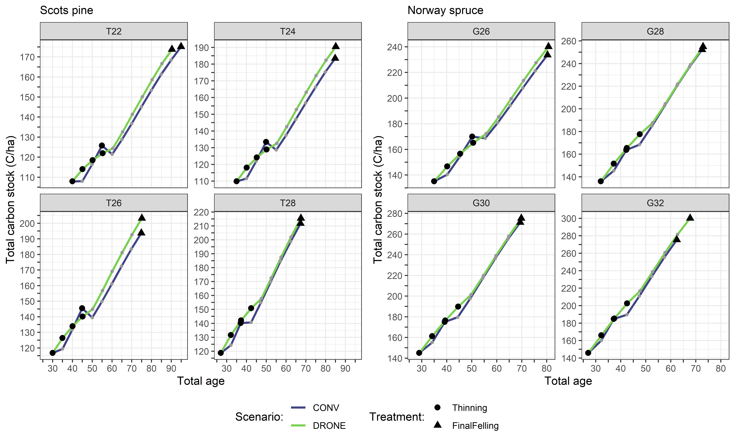

Figure 5.4. Total carbon storage over total age for each site index and respective tree species.

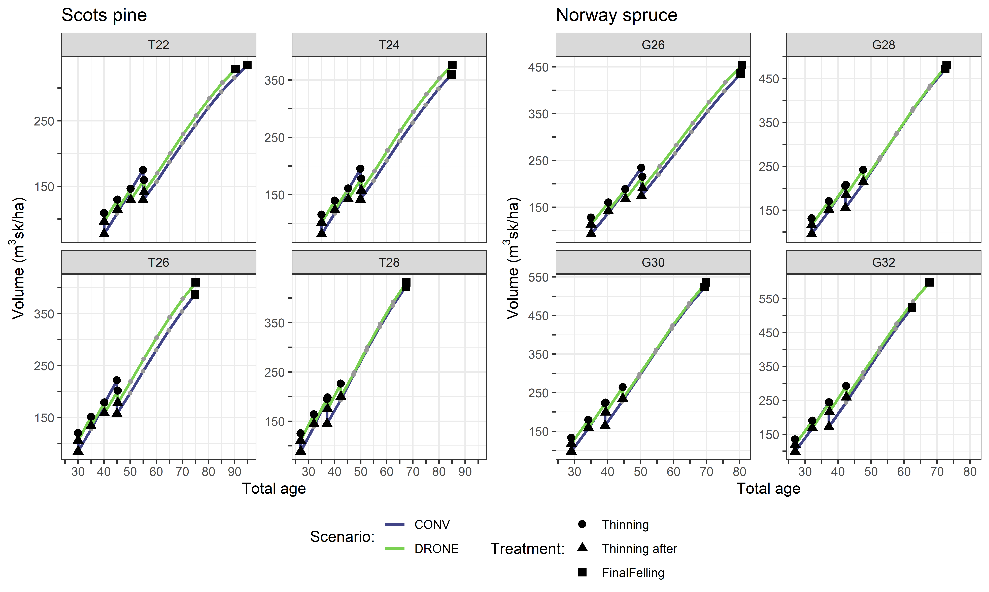

Figure 5.5. Standing volume over total age for each site index and respective tree species.

### Growth

The current annual increment was generally higher for Drone during the rotation, but the marginal difference to CONV did not result in any discernable differences in mean annual increment over the rotation (Figure 5.6.).

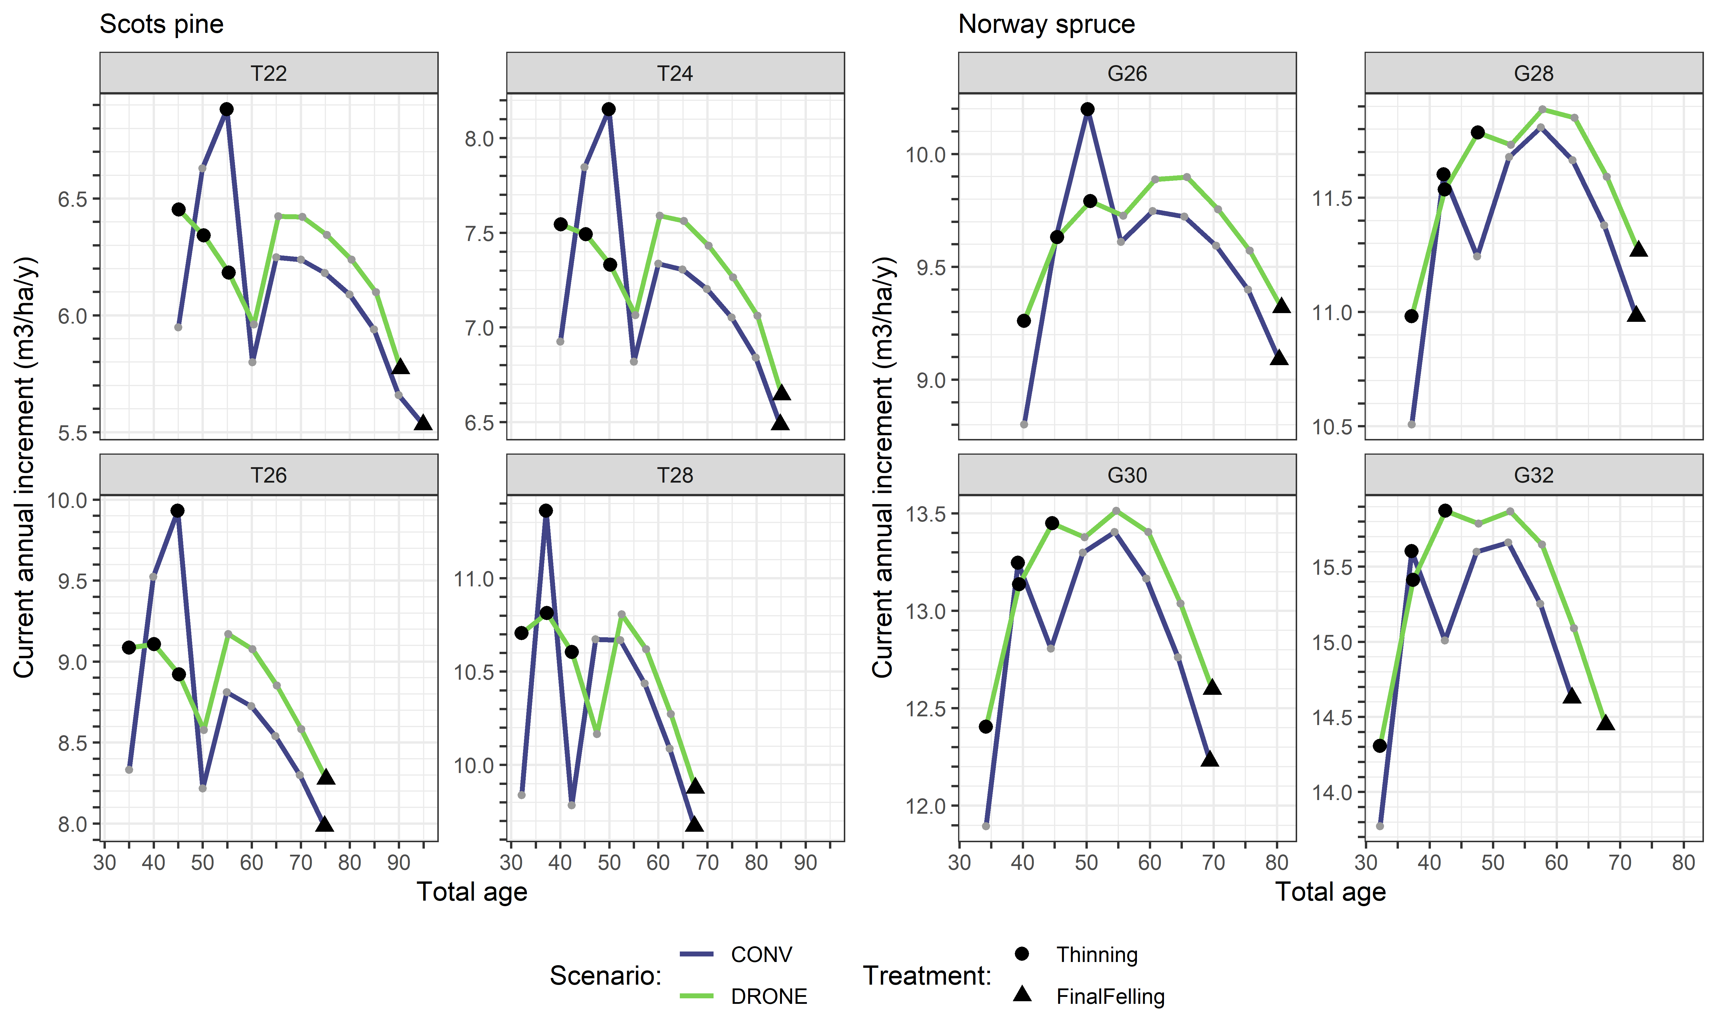

Figure 5.6. Current annual increment over total age for each site index and respective tree species.

### Harvest

The harvested mean stem volume was generally slightly higher for CONV compared to DRONE, given that the thinning was conducted in the same period (Figure 5.7.). This is because the thinning intensity was higher in conventional thinning. The harvested volume per assortment was also comparable over the rotation period (Figure 5.8.).

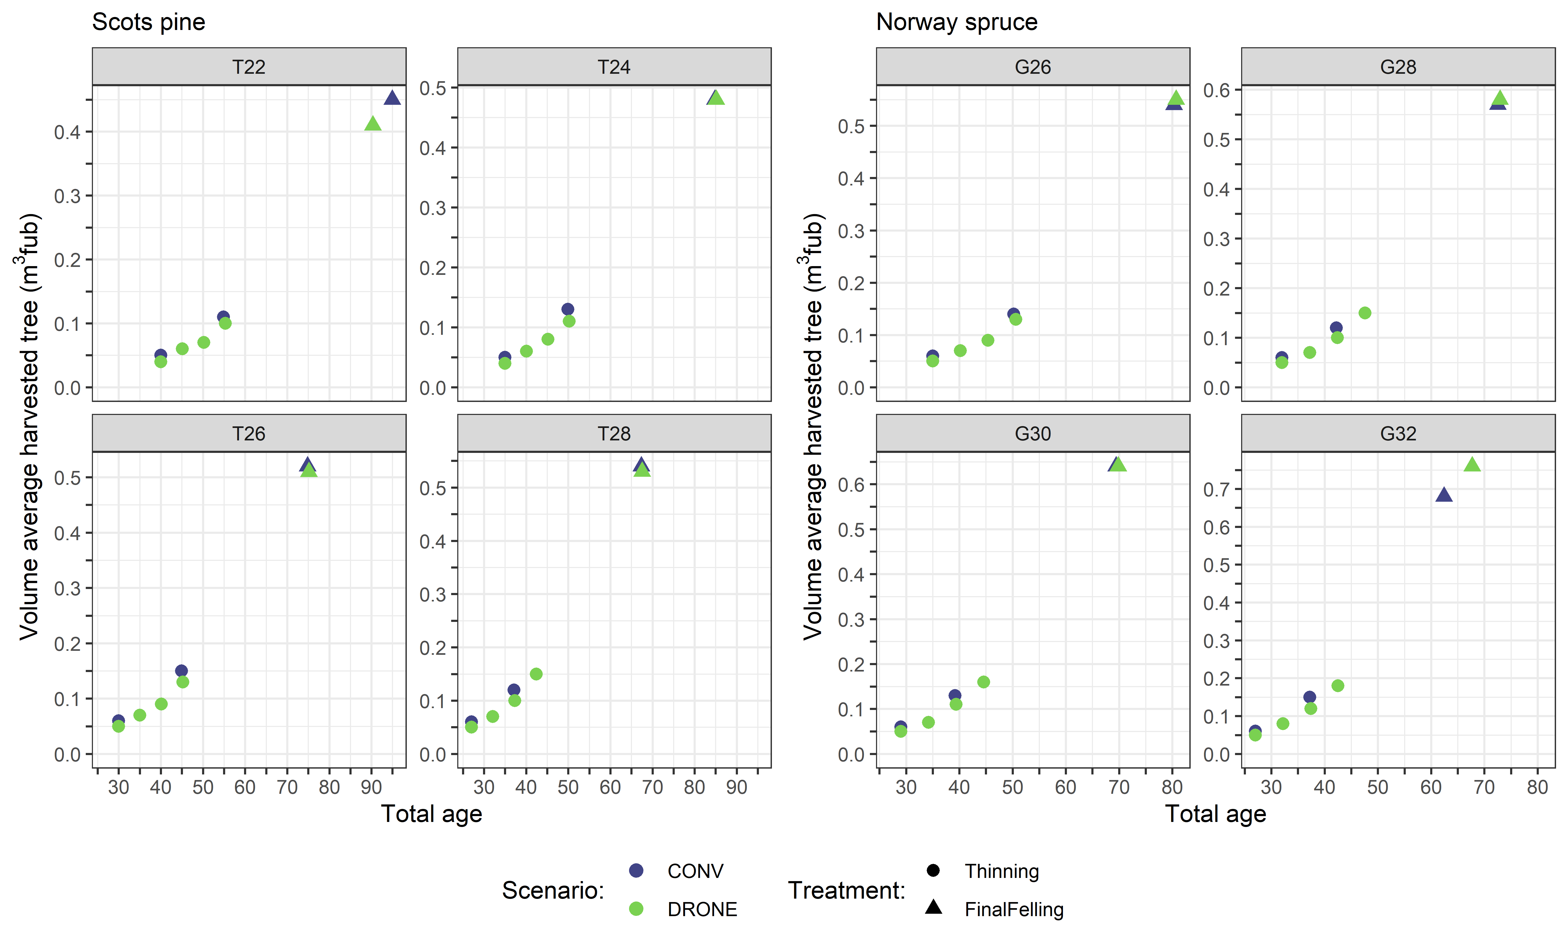

Figure 5.7. Volume average harvested tree over total age for each site index and respective tree species.

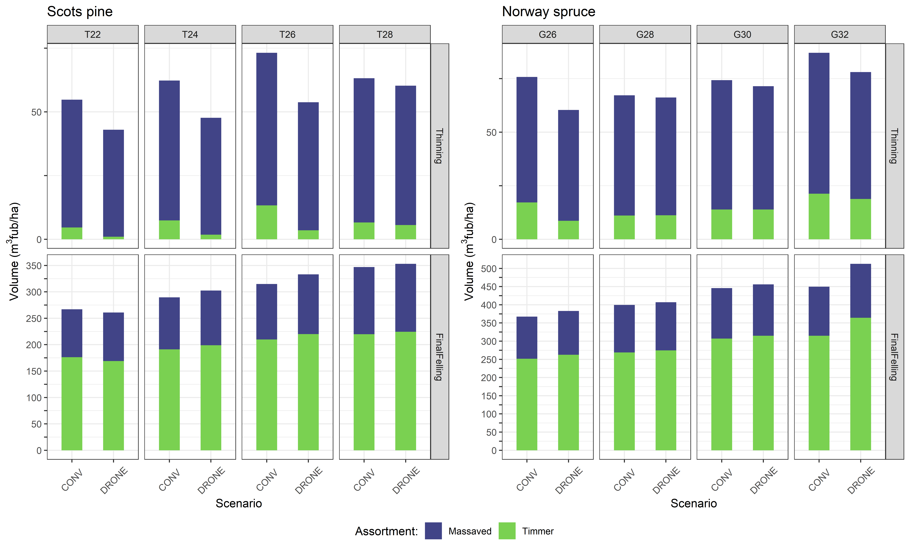

Figure 5.8. Volume of each assortment (timber and pulpwood) per treatment and scenario.

## Discussion

### Simulations

In this study, the potential effect of harvest method (conventional harvester/forwarder and the drone system) on a range of forest attributes was evaluated. The assumptions incorporated in the silvicultural rules in Heureka PlanWise was that the drone system could thin more frequently and with lower thinning intensity. The results from our study are thought to represent thinning of average production stands across a wide range in site productivity, where the forest management objective was to maximize the Land Expectation Value while following the silvicultural recommendations.

This simulations study shows that differences in harvesting method will not produce a different forest in terms of basal area, stem number, standing volume, total carbon stock. Consequently, the current annual increment and mean annual increment and the harvested volume per assortment was also similar over the rotation. The reason behind it is that the temporarily higher growth while thinning with a low intensity was too small. Thus, the result from our simulations suggests that the difference in harvest methods did not create any added benefits given that the same forest management goal was pursued. The circumstances which may lead to differences in tree selection or added growth are likely to be found in stands which contain more complexity than the normal production stand on flat terrain. Future evaluations should incorporate how terrain, tree sizes and tree species may affect productivity, and incorporate estimates productivity of several drones.

The study is limited by the fact that AirForestry drone system is under development and has not yet been tested operationally. Thus, the assumptions for the DRONE scenario were based on what we knew about the drone system when we started the project. Insights from field experience could therefore not be incorporated in any depth into the simulations in Heureka.

The method of manually deriving a thinning intensity for DRONE that ended up with the same stand after the thinning phase was crude. Another way of dealing with it would be to define a restriction in the optimization module, however, Heureka did not manage to produce a viable solution to this problem formulation. However, this alternative method would likely produce a similar thinning regime as the one presented. We argue that a somewhat pure effect of the thinning frequency and thinning intensity was isolated using the current method, which could speak of the difference between the harvesting methods.

### Future forest management trends affecting thinning

There are various trends in forestry today involving forest management which encompass higher stand densities (carbon storage) and lower stand densities (increased drought resilience), which are influence by the thinning regime. There might appear technological gaps in the implementation which the AirForestry drone-system might be better (or worse) suited to deal with.

In a warmer future, reductions in summer rainfall and intensified droughts may affect forest health and ecosystem services in many regions including Fennoscandia (Spinoni et al. 2017). The heatwave in the summer of 2018 exemplifies how drought events may cause water shortage which negatively affect tree growth, mortality and ecosystem functioning. However, thinning reduces competition for water, nutrients and sunlight (Zeide 2001), resulting in improved growth conditions for the remaining trees (Aussenac and Granier 1988, Bréda et al. 1995). Hence thinned stands recover faster and are more resilient to drought-induced growth reductions (Sohn et al. 2016a, Sohn et al. 2016b). Thus, thinning is a promising adaptation and mitigation strategy to drought in young, coniferous production stands, such as the ones included in this study. The role of thinning in a warmer climate and the capability to perform site-specific thinning is therefore likely to become more important with time.

The interest in carbon-offset in European production forests is increasing, and entails maximizing carbon storage over time. Biomass production is strongly related to stand Leaf Area (LA). Thinning reduces LA as trees are removed, and thus non-thinned stands have the highest biomass production and carbon storage. Also, it is likely that either private initiatives or governmental jurisdiction will incentivize forest owners to increase carbon storage by reducing mid-rotation harvest intensities. Airforestrys’ drone system is probably capable of carrying out low-intensity thinning, which makes it a better choice for performing this management objective than the conventional harvester/forwarder system.

These trends will likely increase the need for precise information about specific trees in stands and their growing conditions. Equipping the drones with LiDAR-sensors and hyperspectral cameras will provide the foundation for estimating the size and vitality of single trees. This in combination with returning to the same tree at multiple occasions, might provide the possibility to optimize tree selection (harvest or retain a tree) over the rotation and to utilize more of the growth potential.

1. Salvage logging of spruce bark beetle attacked trees using harvest drones – potential pest control

Petter Öhrn

## Bark beetles in a changing world

During the last decades there has been a strong increase in disturbances of tree-killing bark beetles in all the world’s coniferous forests (Hlásny et al., 2021) and this trend will most likely continue (Seidl et al., 2014). The Eurasian spruce bark beetle (*Ips typographus)* is the most devastating forest pest affecting the Norway spruce (*Picea abies* (L.) H. Karst). Across Europe, its infestations have led to the death of hundreds of millions of cubic meters of spruce wood in recent years (Patacca et al., 2023).

In Sweden, in the years following the drought event in 2018 until 2023 more than 34 million cubic meters of spruce has been killed (Wulff and Roberge, 2023), which represents 75% of all spruce wood killed by spruce bark beetle since the 1960s (Schroeder and Kärvemo, 2022). Only in Sweden the economic loss of the damaged wood during the last years has been estimated to 14 billion SEK according to the Forest agency (Skogsstyrelsen).

## Bark beetle life cycle and phenology

The spruce bark beetle begins to swarm in spring during the first days with temperatures approaching 20°C (Öhrn et al., 2014). After emerging from overwintering, they start to fly, in search of suitable breeding sites within the forest.

Under low, *endemic* population levels, the beetles typically breed in the phloem under the bark of recently dead or dying Norway spruce trees and un-barked timber. When bark beetles reach *epidemic* outbreak levels the beetles can overcome tree defense of living trees. After three weeks when the parent beetles finished mating and gallery construction the parent beetles move on to initiate a sister brood.

Once the first brood (new generation) reaches full maturity, they have several options, depending on thermal conditions and photoperiod. In central Europe, the typical flight pattern involves a fully developed second generation and multiple sister broods. Conversely, in higher altitudes and further north in Europe (e. g Sweden), it's more common to have just one generation with one or several sister broods (Öhrn et al., 2014). How warm the summer has been affects the timing and the proportion of beetles emerging to initiate a second brood. In Sweden, the new generation normally start to emerge around beginning of July (Öhrn et al., 2014). However, commonly the flight activity is low in the second half of the summer. Even, during exceptionally warm summers only a minor part of the new generation in Southern Sweden was estimated to reproduce before hibernation (Fritscher and Schroeder, 2022).

The spruce bark beetle overwinters as adult beetle and larvae and pupae do not survive winter temperatures. Depending on climatic site conditions, the beetles either stay under bark or emerge from the tree during late autumn to overwinter in the soil. In central Europe, the majority of the beetles spend the winter period underneath the bark of either standing or fallen trees (Faccoli, 2002). In the most northern parts of Europe, the spruce bark beetle hibernates under the snow cover within the soil (Annila, 1969). In a recent study conducted by SLU and Skogforsk in southern Sweden (Västmanland to Småland) we observed that in average 63% of the beetles stayed to overwinter underneath the bark of the infested tree (Weslien et al., 2022). Thus, the remaining 37% of the beetles left the trees at some point between the time of emergence of the new generation (around beginning of July) and the onset of winter.

Bark beetle outbreaks are usually triggered by either storm felling (abundance of defenseless breeding substrate), drought (weakened host trees), or a combination of both. However, the spatial configuration, where in the landscape the infested trees are situated may differ depending on what triggered the outbreak. In a comparison between the outbreaks following the storm Gudrun in 2005 and the drought 2018 the infestation risk during the storm induced outbreak increased with shorter distance to protected areas, while the infestation risk during the drought induced outbreak was more dependent on the distance to clear-cut areas (Kärvemo et al., 2023).

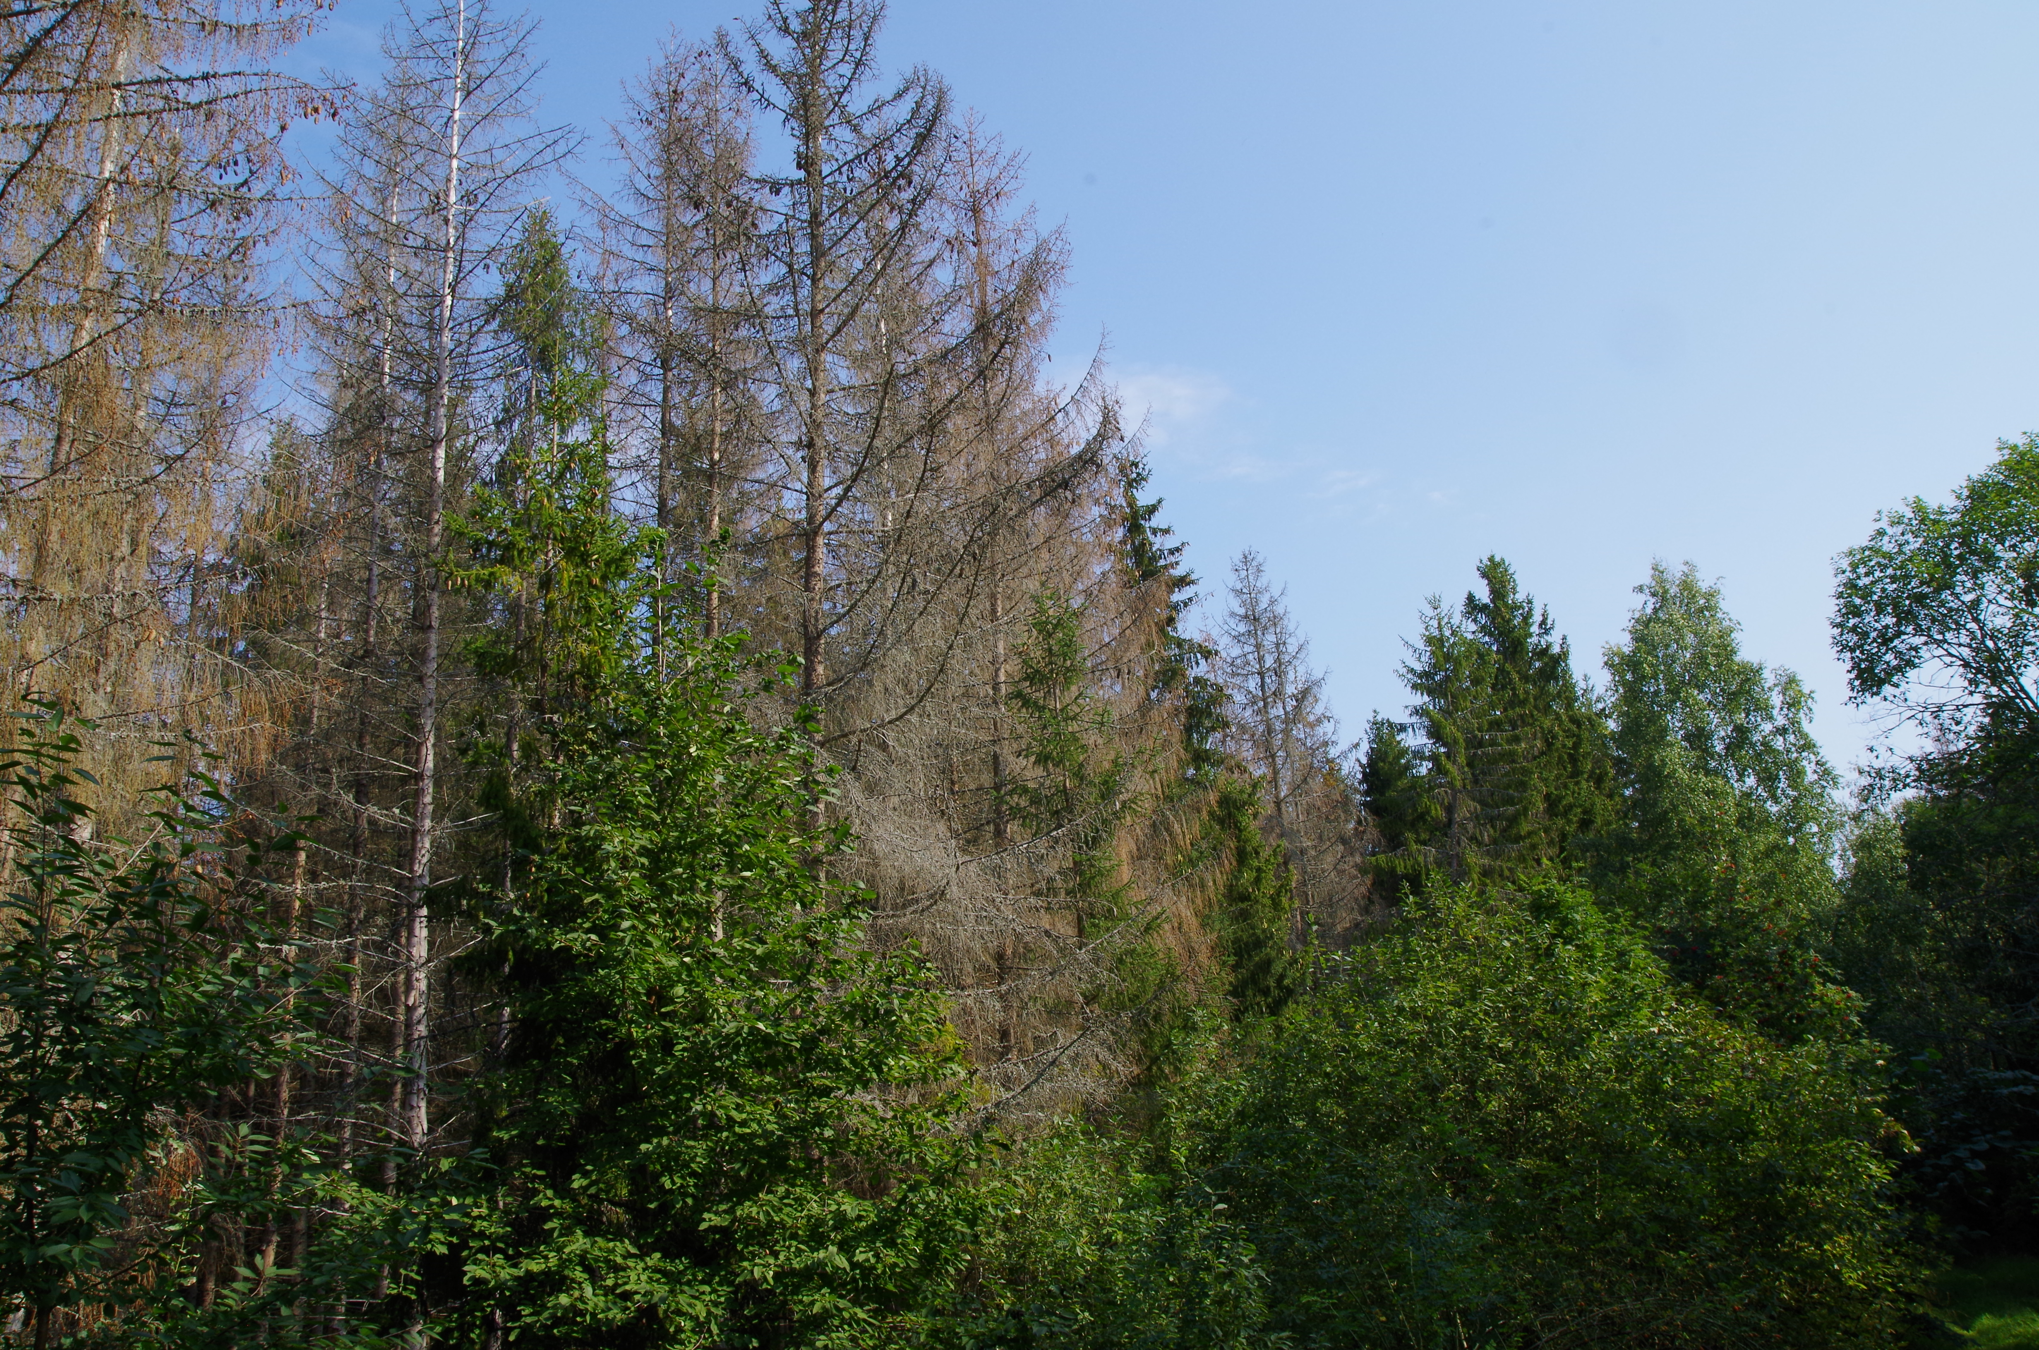

Figure 6.1 Dead spruces trees by spruce bark beetle in a forest just outside of Uppsala. Photo: L. Djupström

## Techniques for early detection of bark beetle infested trees

Historically, ground based human visual inspection has been the only method for detecting bark beetle infested trees. However, early detection of bark beetle infestations can be made with remote sensing and machine learning. A recent review describes the evolution towards automatic detection systems for bark beetle attacks on conifers in both Europe and North America (Marvasti-Zadeh et al., 2023).

At this point the resolution of satellite images is too low to detect bark beetle green attacks on single tree level. Higher resolutions, enough for single tree early detection of bark beetle infestations, have been obtained only in a handful of studies of ariel detection using drones (Bárta et al., 2022; Huo et al., 2023; Klouček et al., 2019; Minařík et al., 2021). These studies could be valuable when developing harvest drone-based methods to control bark beetle control populations. One of the most recent studies, conducted in southern Sweden (Huo et al., 2023), showed that 15% and 90% of infestations were detected after 5 and 10 weeks after initiation of attack, respectively.

Another ground based method is with the aid of the well developed nose of a dog (Vošvrdová et al., 2023). Volotiles from stressed (bark beetle attacked trees) could also be traced with an electronic nose mounted on a drone (Hüttnerová et al., 2023).

## Use of harvest drones as a pest management tool

In forest pest management timing is crucial for successful pest control, both the timing of the action within a season and the timing of the action in relation to bark beetle outbreak phase (Hlásny et al., 2021). On a seasonal scale and tree level the action must be done as early as possible before the new generation emerges from under bark and for best population control effect this action must be done at an early-, population build-up (*endemic*) stage before bark beetle populations reaches *epidemic,* outbreak levels. Pest control efficiency is limited by availability of harvesting machinery during the limited time before the new generation of beetles leave the infested trees.

When the harvester head runs along the stem and debarks the tree the bark will fall to the ground. Bark beetle pupae and larvae will likely dry out and die from this treatment. However, fully developed beetles probably survive unless the debarking process is “violent” enough only leaving small pieces of bark. Different pressures of debarking remain to be tested to further evaluate the method.

The effect of using harvest drones for pest control may not prevent bark beetle outbreaks but could possibly dampen the severity of future outbreaks. For efficient pest control, measures must be taken at a sufficiently large spatial scale since bark beetles can fly long distances.

One limitation in the use of harvest drones as a bark beetle control is that it is only possible to use them on standing beetle infested trees, which means that the use is most effective during a drought induced outbreak when control measures are possible in the first year of outbreak. In contrast, in the case of a storm induced outbreaks the use of harvest drones will be possible first in the second outbreak year when beetles that were produced in the wind-felled trees will attack standing trees.

## Pest control measures and modelling of bark beetle populations

The complexity of outbreak dynamics of bark beetles makes it hard to estimate the effect of different control measures on the development of the outbreak. Though, there have been some attempts to investigate this (Hlásny et al., 2021). There are some modelling studies on drivers of spruce bark beetle infestations on windthrown trees and the effects of timely removal of infested trees (Dobor et al., 2019; Hroššo et al., 2020; Jönsson et al., 2012). Dobor et al (2019) estimated that if less than 95% of the windthrown trees were salvaged (removed) there was no dampening of bark beetle infestations.

More applicable when estimating the effect of the use of harvest drones for reducing bark beetle damage is the IPS-SPREADS model (Infestation Pattern Simulation Supporting PREdisposition Assessment DetailS), showing that sanitation cutting is most effective near the beetle source (Pietzsch et al., 2021). The model is a suggested tool for investigating different management measures on either windthrown or standing beetle-killed trees.

# 7.Concluding remarks

The absence of strip roads is the most obvious advantage of thinning with airborne systems. Strip roads typically cover 18 percent of the stand area after thinning in Swedish operations. Gains in timber production are in the range of 5 to 10 percent higher production per year for a period of 15 to 20 years. The absence of strip roads has other benefits. These include a higher resilience to wind and snow damage. Strip road trees, i.e. trees that have to be removed in conventional operations will not be an issue, meaning that selection of what trees to remove will be freer as will choice of what thinning form to use. The absence of strip roads is of course beneficial from a general environmental standpoint, particularly for the soil ecosystem.

Another benefit of airborne systems is that logging damage may be reduced since there will be no ground-based machinery in the forest. This will help reduce the spread of e.g. root rot. It will however not eliminate the need for stump treatment, and recommendations on timing of operations will apply equally to airborne operations.

Airborne systems may enable an increased use of nurse crops. Nurse crops provide seedlings with shelter from frost, waterlogging and increase stand production during the establishment phase. Establishment and management of nurse crops is complicated and/or costly since shelter trees must be selected, retained and later gradually removed. The gradual removal is a complicated operation using ground-based systems. In today’s forestry, nurse crops are sparingly used, and then mainly to protect spruce seedlings from frost. With an airborne system it is possible that the increased production could motivate an increased use of the treatment.

Areas where entry using ground-based machinery is undesirable, but where small spruce trees need to be removed such as protected areas and buffer zones, offer an opportunity to airborne systems. Operational goals in these areas are not primarily economic and site disturbance should be held at a minimum. Conservation measures can furthermore readily be done at the micro-site level using airborne technologies.

The risk of spreading invasive species could be reduced as the machinery has no ground contact and cannot spread organisms from one site to another.

There is an emerging field of research on remote sensing techniques for detection of beetle infested trees. Timely removal of infested trees is considered a key measure to reduce bark beetle populations but is hard to achieve in practice. Pest control efficiency is limited by harvesting machinery during the time window before the new generation of beetles leave the infested trees. Properly adapted, the use of harvest drones could contribute to pest control, probably not prevent bark beetle outbreaks but could possibly contribute to dampen the severity of future outbreaks.

The technological differences between an aerial drone system and conventional harvesting systems are not likely to result in changes in stand development or forest production under the same forest management goals.

Harvester heads working their way down stems means that there will be problems with trees with cymose growth, i.e. many broadleaves and with big and deformed trees. Trees below the canopy will be difficult to harvest. Combined with the limitations on big and deformed trees and the potential problems with broadleaves, stand structure may change in stands thinned with airborne systems. Diameter distribution will be wider, and composition may be different from that of conventional operations. This is not necessarily a drawback from an environmental standpoint. Understoreys, important structures providing shelter and/or food can be kept intact.

Environmental drawbacks of airborne systems include the noise generated by the drone, and maybe its mere presence. Extraction of whole stems means that treetops will not be left on the forest floor where they form fine substrates. The possibility of reaching technical impediments can endanger disturbance-sensitive species if careful consideration of these refugia is not considered.

Harvesting small trees leads to low productivity, and thus high costs, due to low load weights. Compared to harvester-forwarder systems, a system with only one aerial drone is not an economically viable option for thinning in the analysed scenario “normal speed and normal positioning time”. In the faster scenarios competitive drone thinning operations are doubtful. If an operator could handle multiple drones, the scope for competitive operations increases.

The ability of an aerial drone system to thin with a lower intensity and manage stand density may facilitate adaptation toward climate change and to mitigate competition induced risks (drought, bark beetle, mortality). However, this shift depends on developing methods which result in reduced variable and fixed costs and a high flexibility in harvesting technique compared to conventional harvesting systems. With that said, aerial drones need not necessarily carry harvester heads. They could instead be equipped with grapples and used for extraction only. In such a system harvesting could be done by small harvesters operating from ghost trails. A grapple will not be as heavy as a harvester head, enabling the drone to handle bigger trees. If harvesting is done by a ground-based harvester, broadleaves and bigger and/or deformed trees may no longer be an issue. Safety aspects dictate that airborne systems are unacceptable in inhabited areas or in areas used for recreation, unless the areas treated can be closed to public access.

Electricity-based technology development is in line with the objective of reducing carbon dioxide emissions and improving air quality. A transition to fossil-free vehicles in the forestry sector can reduce the sector's environmental footprint while being beneficial for its economy and future. The forest sector can strengthen its market position by adopting fossil-free vehicles, which can be a differentiating factor and increase the demand for forest-based products from environmentally conscious consumers and companies.

Referenser

Agestam, E. 2015. Gallring. Skogsskötselserien Nr. 7. Skogsstyrelsen. Jönköping https: [www.skogsstyrelsen.se/mer-om-skog/skogsskotselserien/skogsskotselserien--gallring/](http://www.skogsstyrelsen.se/mer-om-skog/skogsskotselserien/skogsskotselserien--gallring/) [2024-02-07].

Air Forestry Undated. Re-inventing forestry. <https://www.airforestry.com/> [2024-02-07].

Albrektson A, Elfving B, Lundqvist L, Valinger E (2012) Naturhänsyn. Skogsskötselserien, Chapter 14. Second edition. <https://www.skogsstyrelsen.se/mer-om-skog/skogsskotselserien/naturhansyn/> [2024-02-07].

Andersson, L. 1980. Skador efter körning med tunga maskiner I gallring. Omfattning, orsaker och effecter på beståndets tillväxt och kvalitet. Institutionen för skogsskötsel, Interna rapporter 1980-4. SLU, Umeå.

Annila, E. 1969. Influence of temperature upon the development and voltinism of Ips typographus L.(Coleoptera, Scolytidae), Annales Zoologici Fennici. JSTOR 6(2): 161-208.

Anon 1994. Skogsordlista. Tekniska nomenklaturcentralens publikationer 96 & Sveriges skogsvårdsförbund.

Aussenac, G. & Granier, A. 1988. Effects of thinning on water stress and growth in Douglas-fir. Canadian Journal of Forest Research 18:100-105. DOI: 10.1139/x88-015

Banu, T.P., Borlea G.F. & Banu, C. 2016. The use of drones in forestry. Journal of Environmental Science and Engineering 5(2016): 557-562. DOI: 10.17265/2162-5263/2016.11.007

Bárta, V., Hanuš, J., Dobrovolný, L. & Homolová, L. 2022. Comparison of field survey and remote sensing techniques for detection of bark beetle-infested trees. Forest Ecology and Management, 506: 119984. <https://doi.org/10.1016/j.foreco.2021.119984>

Bergquist, J., Edlund, S., Fries, C.,Gunnarsson, S., Hazell, P., Karlsson, L., Lomander, A., Näslund, B-Å., Rosell, S., Stendahl, J. 2016. Kunskapsplattform för skogsproduktion - Tillståndet i skogen, problem och tänkbara insatser och åtgärder. Meddelande 1. 2016. Skogsstyreslen. Jönköping.

Bergkvist, I., Hallonborg, U., & Nordén, B. 2002. Valmet 801 Combi i gallring med fast lastutrymme för standardlängder. Arbetsrapport Nr. 518. Skogforsk, Uppsala. [www.skogforsk.se/cd_20190114162210/contentassets/ff22339dda8c49e98f80d8c196b21d30/arbetsrapport-518-2002.pdf](http://www.skogforsk.se/cd_20190114162210/contentassets/ff22339dda8c49e98f80d8c196b21d30/arbetsrapport-518-2002.pdf) [2024-02-07].

Bigsby, H. & Ling, P. 2013. Long-term productivity of helicopter logging in Sarawak. International Journal of Forest Engineering 24(1): 24-30 DOI: 10.1080/19132220.2013.791197

Björheden, R., Gustavsson, H., Henriksen, F., Lundström, H. & Olsson, A. 2018. Utvärdering av maskinsystemet MALWA för tidig gallring. Arbetsrapport 9722018. Skogforsk, Uppsala. <https://www.skogforsk.se/contentassets/82a4696935a34522a13fad49f42bad42/arbetsrapport-972-2018.pdf> [2024-02-07].

Bréda, N., Granier, A., & Aussenac, G. 1995. Effects of thinning on soil and tree water relations, transpiration and growth in an oak forest (Quercus petraea (Matt.) Liebl.). Tree Physiol 15:295-306. <https://doi.org/10.1093/treephys/15.5.295>

Bredberg, C.J. 1972. Typbestånd i förstagallringar. Skogshögskolan, Institutionen för skogsteknik., Rapporter och uppsatser

Brin, A., Bouget, C., Brustel, H. & Jactel, H. 2011. Diameter of downed woody debris does matter for saproxylic beetle assemblages in temperate oak and pine forests. Journal of Insect Conservation, 15(5), 653–669. <https://doi.org/10.1007/S10841-010-9364-5/TABLES/5>

Bucht, S. 1981. Effekten av några olika gallringsmönster på beståndsutvecklingen i tallskog. Swedish University of Agricultural Sciences, Department of Silviculture Report nr 4

Conway, S. 1982. Logging Practices - Principles of Timber Harvesting Systems. San Francisco, Miller Freeman Inc.

Deep Forestry 2022. Do you know every tree in your forest – we do. <https://deepforestry.com/sv/> [2024-02-07].

Dobor, L., m.fl. 2019. Is salvage logging effectively dampening bark beetle outbreaks and preserving forest carbon stocks? Journal of Applied Ecology, 57(1): 67-76. <https://doi.org/10.1111/1365-2664.13518>

Dykstra, D.P., Aulerich D.E. & Henshaw, J.R. 1978. Prebunching to Reduce Helicopter Logging Costs. Journal of Forestry 76(6): 362-364. <https://doi.org/10.1093/jof/76.6.362>

Ekö, M. 1985. Produktionsmodell för skog i Sverige, baserad på bestånd från riksskogstaxeringens provytor. Swedish University of Agricultural Sciences, Department of Silviculture

Eliasson, L. 2021. Kostnader i det storskaliga skogsbruket 2020 ( JO – Jordbruk, skogsbruk och fiske, Issue.

Eliasson, L. 2022. Skogsbrukets kostnader och intäkter 2021 (*Costs and revenues in Swedish forestry 2021*). Skogforsk

Eriksson, H., Johansson, U. & Karlsson, K. 1994. Effekter av stickvägsbredd och gallringsform på beståndsutvecklingen i ett försök i granskog. SLU, inst. för skogsproduktion. Rapport nr. 38.

Esseen, P.A., Ehnström, B., Ericson, L., & Sjöberg, K. 1997. Boreal Forests. Ecological Bulletins, 46, 16–47. <http://www.jstor.org/stable/20113207> [2024-02-07].

Faccoli, M. 2002. Winter mortality in sub-corticolous populations of *Ips typographus* (Coleoptera, Scolytidae) and its parasitoids in the south-eastern Alps. Anzeiger für Schädlingskunde. Journal of pest science, 75(3): 62-68. <https://doi.org/10.1034/j.1399-5448.2002.02017.x>

Ford-Robertson, F.C. (ed) 1971. Terminology of forest science, technology practice and products. Society of American Foresters, Washington

Forest Stewardship Council 2015. Forest Stewardship Council FSC INTERNATIONAL STANDARD (Vol. 005). <https://ic.fsc.org/preview.fsc-principles-and-criteria-for-forest-stewardship-fsc-std-01-001-v5-2-en-print-version.a-4843.pdf> [2024-02-07].

Forman, R.T. & Alexander LE (1998). Roads and their major ecological effects. Annual review of ecology and systematics, 29(1): 207-231 <https://doi.org/10.1146/annurev.ecolsys.29.1.207>

Fridman, J., & Walheim, M. 2000. Amount, structure, and dynamics of dead wood on managed forestland in Sweden. Forest Ecology and Management, 131(1–3), 23–36. <https://doi.org/10.1016/S0378-1127(99)00208-X>

Fritscher, D. & Schroeder, M. 2022. Thermal sum requirements for development and flight initiation of new-generation spruce bark beetles based on seasonal change in cuticular colour of trapped beetles. Agricultural and Forest Entomology, 24(3), 405–421. <https://doi.org/10.1111/afe.12503>.

Föreningen skogen 2000. Skogsencyklopedin (Håkansson M. redaktör).

Grinddrone Undated. 15 uses of drones in forestry. <https://grinddrone.com/applications/15-uses-of-drones-in-forestry> [2024-02-07].

Grönesjö, R. 2016. Viktiga faktorer för skogsägare vid gallring. *Important factors for the forest owners in thinning*. B.Sc Thesis 2016-28, School of Forest Management, Skinnskatteberg, Sweden <https://stud.epsilon.slu.se/9664/1/gronesjo_r_20160927.pdf> [2024-02-07].

Grönlund, Ö. & Eliasson, L. 2019. Birch shelterwood removal – harvester and forwarder time consumption, damage to understory spruce and net revenues, International Journal of Forest Engineering, 30:1, 26-34, DOI: 10.1080/14942119.2019.1595943

Häggström, K. & Svangärd L. 2022. Drönaranvändning i gallringsskog. Flygande gallring – en teoretisk analys av drönares potential. (*Drone usage in thinning forests*). SLU, Department of Forest Biomaterials and Technology. <https://stud.epsilon.slu.se/17892/3/haggstrom-k-svangard-l-20220629.pdf> [2024-02-07].

Han, H.S. & Kellogg, L. D. 2000. Damage Characteristics in Young Douglas-Fir Stands from Commercial Thinning with Four Timber Harvesting Systems. Western Journal of Applied Forestry 15(1): 27-33. <https://doi.org/10.1093/wjaf/15.1.27>

Heilmann-Clausen, J., & Christensen, M. (2004). Does size matter?: On the importance of various dead wood fractions for fungal diversity in Danish beech forests. Forest Ecology and Management, 201(1), 105–117. [https://doi.org/10.1016/J.FORECO.2004.07.010](https://doi.org/10.1016/J.FORECO.2004.07.010%E2%80%AF)

Helms, J.A., 1998, The Dictionary of Forestry. CABI Publishing & Society of American Foresters.

Hlásny, T., König, L., Krokene, P. et al. Bark Beetle Outbreaks in Europe: State of Knowledge and Ways Forward for Management. Curr Forestry Rep 7, 138–165 (2021). <https://doi.org/10.1007/s40725-021-00142-x>

Hroššo, B.; Mezei, P.; Potterf, M.; Majdák, A.; Blaženec, M.; Korolyova, N.; Jakuš, R. Drivers of Spruce Bark Beetle (*Ips typographus*) Infestations on Downed Trees after Severe Windthrow. *Forests* 2020, *11*, 1290. <https://doi.org/10.3390/f11121290>

Huo, L., Lindberg, E., Bohlin, J. and Persson, H.J., 2023. Assessing the detectability of European spruce bark beetle green attack in multispectral drone images with high spatial-and temporal resolutions. Remote Sensing of Environment, 287: <https://doi.org/10.1016/j.rse.2023.113484>

Hüttnerová, T., Paczkowski, S., Neubert, T., Jirošová, A. and Surový, P., 2023. Comparison of Individual Sensors in the Electronic Nose for Stress Detection in Forest Stands. Sensors, 23(4): 2001. <https://doi.org/10.3390/s23042001>

Jacobsson S., 2015. Lågskärm av björk på granmark – modellering av beståndsutveckling och ekonomisk analys (*The use of birch as a shelter in young Norway spruce stands – modelling stand development and economic outcome*). Skogforsk Arbetsrapport Nr. 876-2015. <https://www.skogforsk.se/contentassets/01d66d3c421c447eb6de2a687ed73374/arbetsrapport-876-2015-lagskarm-av-bjork-pa-granmark.pdf> [2024-02-07].

Joelsson, K. 2017. Uneven-aged silviculture as a management tool to mitigate biodiversity loss. Sveriges lantbruksuniv, Umeå.

Johannesson T. & Hyll K., 2022. Högkapacitetsdrönare för skogsbrandsbekämpning – förutsättningar för användbarhet. Skogforsk Arbetsrapport 1106–2022. <https://www.skogforsk.se/cd_20220214143520/contentassets/93507aa384e7433d99875bb4292f64a3/arbetsrapport-1106-2022.pdf> [2024-02-07].

Johansson, T., 2014. Tillväxt och produktion hos skärmbestånd med björk och gran. Sveriges Lantbruksuniversitet, Institutionen för energi och teknik, Rapport 068, Uppsala,

Jönsson, A.M., Schroeder, L.M., Lagergren, F., Anderbrant, O. & Smith, B. 2012. Guess the impact of Ips typographus—An ecosystem modelling approach for simulating spruce bark beetle outbreaks. Agricultural and Forest Meteorology, 166-167: 188-200. <https://doi.org/10.1016/j.agrformet.2012.07.012>

Jonsson R., 2023. Perso Jonsson R., 2023. Personal communication. nal communication.

Kight, C.R. & Swaddle, J.P. (2011), How and why environmental noise impacts animals: an integrative, mechanistic review. Ecology Letters, 14: 1052-1061. <https://doi.org/10.1111/j.1461-0248.2011.01664.x>

Klein, J. (2020). The forgotten forest: On thinning, retention, and biodiversity in the boreal forest [Swedish University of Agricultural Sciences]. <http://urn.kb.se/resolve?urn=urn:nbn:se:slu:epsilon-p-107783>  [2024-02-07].

Kouki, J., Löfman, S., Martikainen P., Rouvinen, S. & Uotila, A. 2001 Forest Fragmentation in Fennoscandia: Linking Habitat Requirements of Wood-associated Threatened Species to Landscape and Habitat Changes, Scandinavian Journal of Forest Research, 16:sup003, 27-37, DOI: [10.1080/028275801300090564](https://doi.org/10.1080/028275801300090564)

Lageson, H. 1996. Thinning from Below or Above? Implications on operational efficiency and residual stand. Acta universitatis arriculturae sueciae, Silvestria Nr. 14 Swed. Uni. Agr. Sci., 25 p.

Lageson H., 1997. Effects of thinning type on the harvester productivity and on the residual stand. Journal of Forest Engineering 8(2): 7–14. DOI 10.1080/08435243.1997.10702699.

Lindbladh, M., & Abrahamsson, M. (2008). Beetle diversity in high-stumps from Norway spruce thinnings. Scandinavian Journal of Forest research, 23(4), 339–347. <https://doi.org/10.1080/02827580802282762>

Lundbäck, M., Häggström, C. & Nordfjell, T. 2021. Worldwide trends in methods for harvesting and extracting industrial roundwood. International Journal of Forest Engineering 32(3): 202-215 <https://doi.org/10.1080/14942119.2021.1906617>

Kärvemo, S., Huo, L., Öhrn, P., Lindberg, E. & Persson, H. 2023. Different Triggers, Different Stories: Bark-Beetle Infestation Patterns after Storm and Drought-Induced Outbreaks. Forest Ecology and Management, 545. <https://doi.org/10.1016/j.foreco.2023.121255>

Klouček, T. et al. 2019. The Use of UAV Mounted Sensors for Precise Detection of Bark Beetle Infestation. Remote Sensing 11(13): 1561. <https://doi.org/10.3390/rs11131561>

Lämås, T., Sängstuvall, L., Öhman, K., Lundström, J., Årevall, J., Holmström, H., Nilsson, L., Nordström, E.-M., Wikberg, P.-E., Wikström, P., & Eggers, J. (2023). The multi-faceted Swedish Heureka forest decision support system: context, functionality, design, and 10 years experiences of its use. Frontiers in Forests and Global Change, 6. <https://doi.org/10.3389/ffgc.2023.1163105>

Lundmark T., Bergh J., Hofer P., Lundström A., Nordin A., Poudel B.C., Sathre R., Taverna R. & Werner F., 2014. Potential roles of Swedish forestry in the context of climate change mitigation. Forests 5(4): 557-578. <https://doi.org/10.3390/f5040557>

Lundqvist, L., Mörling, T. & Valinger, E. 2014. Spruce and birch growth in pure and mixed stands in Sweden. The Forestry Chronicle 90(1): 29–34.

MacDonald, A. J. 1999. Harvesting Systems and equipment in British Columbia. Victoria, B.C. Ministry of Forests. [1999, Harvesting systems and equipment in British Columbia (gov.bc.ca)](https://www.for.gov.bc.ca/hfd/pubs/docs/sil/sil468.htm) [2024-02-07].

Marvasti-Zadeh, S.M., Goodsman, D., Ray, N. & Erbilgin, N. 2023. Early Detection of Bark Beetle Attack Using Remote Sensing and Machine Learning: A Review. arXiv preprint arXiv:2210.03829.   
<https://doi.org/10.48550/arXiv.2210.03829>

Minařík, R., Langhammer, J. & Lendzioch, T. 2021. Detection of Bark Beetle Disturbance at Tree Level Using UAS Multispectral Imagery and Deep Learning. Remote Sensing, 13(23): 4768 <https://doi.org/10.3390/rs13234768>

Mulero-Pázmány, M., Jenni-Eiermann, S., Strebel, N., Sattler, T., Negro, J.J. & Tablado, Z. 2017. Unmanned aircraft systems as a new source of disturbance for wildlife: A systematic review. PLoS ONE 12(6): e0178448. <https://doi.org/10.1371/journal.pone.0178448>

Nikooy, M., Tavankar, F., Naghdi, R., Ghorbani, A., Jourgholami, M. & Picchio , R. 2020. Soil impacts and residual stand damage from thinning operations, International Journal of Forest Engineering, 31:2, 126-137, DOI: 10.1080/14942119.2020.1744954

Nordén, J., Penttilä, R., Siitonen, J., Tomppo, E. & Ovaskainen, O. 2013. Specialist species of wood-inhabiting fungi struggle while generalists thrive in fragmented boreal forests. J Ecol, 101: 701-712. <https://doi.org/10.1111/1365-2745.12085>

Öhrn, P., Långström, B., Lindelöw, Å. and Björklund, N., 2014. Seasonal flight patterns of *Ips typographus* in southern Sweden and thermal sums required for emergence. Agricultural and Forest Entomology, 16(2): 147-157.

Patacca, M. et al., 2023. Significant increase in natural disturbance impacts on European forests since 1950. Global Change Biology, 29(5): 1359-1376.

Patriquin, K.J. and Barclay, R.M.R. (2003), Foraging by bats in cleared, thinned and unharvested boreal forest. Journal of Applied Ecology, 40: 646-657. <https://doi.org/10.1046/j.1365-2664.2003.00831.x>

Peltoniemi, M., Penttilä, R., & Mäkipää, R. (2013). Temporal variation of polypore diversity based on modelled dead wood dynamics in managed and natural Norway spruce forests. Forest Ecology and Management, 310, 523–530. <https://doi.org/10.1016/J.FORECO.2013.08.053>

Philip M.S., 1994. Measuring Trees and Forests. CABI International

Pienaar, L. V. (1979). An Approximation of Basal Area Growth after Thinning Based on Growth in Unthinned Plantations. Forest Science, 25(2), 223-232. <https://doi.org/10.1093/forestscience/25.2.223>

Pietzsch, B.W., Peter, F.J. & Berger, U. 2021. The Effect of Sanitation Felling on the Spread of the European Spruce Bark Beetle—An Individual-Based Modeling Approach. Front. For. Glob. Chang, 4: 103. <https://doi.org/10.3389/ffgc.2021.704930>

Ranius, T., Kindvall, O., Kruys, N., & Jonsson, B. G. (2003). Modelling dead wood in Norway spruce stands subject to different management regimes. Forest Ecology and Management, 182(1–3), 13–29. <https://doi.org/10.1016/S0378-1127(03)00027-6>

Rauschert, E. S. J., Mortensen, D. A., & Bloser, S. M. (2017). Human-mediated dispersal via rural road maintenance can move invasive propagules. Biological Invasions, 19, 2047–2058. [https://doi](https://doi/).org/10.1007/s10530-017-1416-2

Sandström, P., Cory, N., Svensson, J., Hedenås, H., Jougda, L. & Borchert, N. 2016. On the decline of ground lichen forests in the Swedish boreal landscape: Implications for reindeer husbandry and sustainable forest management. Ambio 45, 415–429. <https://doi.org/10.1007/s13280-015-0759-0>

Schroeder, L.M. & Kärvemo, S. 2022. Rekordstort utbrott av granbarkborre – orsaker och vad man kan göra Friska skogar – så når vi dit – KSLAT nr 7-2022, Stockholm.

Schweier, J., Werder, M. & Bont, L. G. 2023. Timber Provision on Soft Soils in Forests Providing Protection Against Natural Hazards: A Productivity and Cost Analysis Using the Koller 507 in the Horizontal Yarding Direction in Switzerland. Small-scale Forestry 22(2): 271-301.10.1007/s11842-022-09526-8 <https://doi.org/10.1007/s11842-022-09526-8>

Seibold, S., Hagge, J., Müller, J., Gruppe, A., Brandl, R., Bässler, C., & Thorn, S. (2018). Experiments with dead wood reveal the importance of dead branches in the canopy for saproxylic beetle conservation. Forest Ecology and Management, 409, 564–570. <https://doi.org/10.1016/J.FORECO.2017.11.052>

Seidl, R., Schelhaas, M.J., Rammer, W. & Verkerk, P.J. 2014. Increasing forest disturbances in Europe and their impact on carbon storage. Nat Clim Chang, 4(9): 806-810. <https://doi.org/10.1038/nclimate2318>

Siitonen, J. 2001. Forest Management, Coarse Woody Debris and Saproxylic Organisms: Fennoscandian Boreal Forests as an Example. Ecological Bulletins 49: 11–41. DOI: 10.2307/20113262

Sippola, A. L., Lehesvirta, T., & Renvall, P. 2001. Effects of selective logging on coarse woody debris and diversity of wood-decaying polypores in eastern Finland. Ecological Bulletins, 243-254.

Sirén, M., Ilomäki J.A., Mäkinen H., Lamminen S. & Mikkola T., 2013. Harvesting damage caused by thinning of Norway spruce in unfrozen soil, International Journal of Forest Engineering, 24:1, 60-75, DOI: [10.1080/19132220.2013.792155](https://doi.org/10.1080/19132220.2013.792155)

Skogskunskap 2016. Gallringsmall för barr och löv - Skogskunskap. <https://www.skogskunskap.se/rakna-med-verktyg/skogsvard/gallringsmall/> (accessed 2024-01-09)

Skogsstyrelsen. 2008. Rekommendationer vid uttag av avverkningsrester och askåterföring. Skogsstyrelsen, Jönköping. Meddelande Nr. 2-2008.

Södra 2017. Södra investerar i fler drönare. Tidningen Skogen, <https://www.skogen.se/nyheter/sodra-investerar-i-fler-dronare> [2022-09-21]

Sohn, J. A., F. Hartig, M. Kohler, J. Huss, & J. Bauhus. 2016. Heavy and frequent thinning promotes drought adaptation in Pinus sylvestris forests. Ecological Applications 26:2190-2205. <https://doi.org/10.1002/eap.1373>

Sohn, J. A., S. Saha, & J. Bauhus. 2016. Potential of forest thinning to mitigate drought stress: A meta-analysis. Forest Ecology and Management 380:261-273. <https://doi.org/10.1016/j.foreco.2016.07.046>

Spinoni, J., Vogt, J.V., Naumann, G., Barbosa, P. & Dosio, A. 2018. Will drought events become more frequent and severe in Europe?. Int. J. Climatol, 38: 1718-1736. <https://doi.org/10.1002/joc.5291>

Stampfer, K., Gridling, H. & Visser, R. 2002. Analyses of Parameters Affecting Helicopter Timber Extraction. International Journal of Forest Engineering 13(2): 61-68. <https://doi.org/10.1080/14942119.2002.10702463>

Stenbacka, F., Hjältén, J., Hilszczański, J., & Dynesius, M., 2010. Saproxylic and non-saproxylic beetle assemblages in boreal spruce forests of different age and forestry intensity. Ecological Applications, 20(8), 2310–2321. <https://doi.org/10.1890/09-0815.1>

Strengbom, J, Axelsson, E.P., Lundmark, T., Nordin, A. 2018. Trade-offs in the multi-use potential of managed boreal forests. J Appl Ecol. 55: 958– 966. <https://doi.org/10.1111/1365-2664.13019>

Tham, Å. 1988. Yield prediction after heavy thinnings of birch in mixed stands of Norway spruce (Picea abies (L.) Karst.) and birch (Betula pendula Roth & Betula pubescens Ehrh.). SLU, Institutionen för skogsproduktion, Rapport 23, Garpenberg, 36

Thibault, M., & Moreau, G. 2016. The amplitude of dead wood resource pulses produced by plantation thinning mediates the assembly of wood-boring beetles. Ecosphere, 7(2), e01215. <https://doi.org/10.1002/ECS2.1215/SUPINFO>

Tobajas, J., Guil, F., & Margalida, A. 2022. Effects of free-flight activities on wildlife: A poorly understood issue in conservation. Environmental Conservation, 49(1): 8-16. doi:10.1017/S0376892921000412

Transportstyrelsen 2022. Drönare – Utbildningsmaterial. Revision 2022-MAR-30. [A2-A1A3 utbildningsmaterial 2022-MAR-30 (transportstyrelsen.se)](https://transportstyrelsen.se/globalassets/global/luftfart/dronare/utbildningsmaterial/dronare-a1-a3-utbildning.pdf), [2022-09-21]

Uusitalo J, 2010. Introduction to Forest Operations and Technology. JVP Forest Systems OY. Tavastehus, Finland.

Valinger, E., & Pettersson, N. 1996. Wind and snow damage in a thinning and fertilization experiment in Picea abies in southern Sweden. Forestry: An International Journal of Forest Research, *69*(1), 25-33. <https://doi.org/10.1093/forestry/69.1.25>

Vošvrdová, N. et al., 2023. Dogs trained to recognise a bark beetle pheromone locate recently attacked spruces better than human experts. Forest Ecology and Management, 528: 120626. <https://doi.org/10.1016/j.foreco.2022.120626>

Wasterlund, I. 2020. Soil and root damage in forestry: reducing the impact of forest mechanization. Elsevier.

Weslien, J., Schroeder, M. and Öhrn, P., 2022. Effekt på granbarkborren och dess fiender vid vinteravverkning av dödade granar, Skogforsk. <https://www.skogforsk.se/kunskap/kunskapsbanken/2022/effekt-pa-granbarkborren-och-dess-fiender-vid-vinteravverkning-av-dodade-granar/> [2024-02-07].

Widenfalk, O., & Weslien, J. 2009. Plant species richness in managed boreal forests—Effects of stand succession and thinning. Forest ecology and management, 257(5): 1386-1394.  <https://doi.org/10.1016/j.foreco.2008.12.010>

Wilhelmsson E., Möller J. & Ahrlinger J., 2019. Betalningsgrundande eller betalningsstödjande virkesmätning med skördare. (Cut-To-Length harvester measurements for roundwood payment to forest owners or for supporting industrial pile measurements). Arbetsrapport 1032-2019. Skogforsk. <https://www.skogforsk.se/cd_20200203142819/contentassets/3fece182fb8f458dbdf3e59a81d8625a/arbetsrapport-1032-2019.pdf> [2024-02-07].

Worell, R. & Hampson, A. 1997. The influence of some forest operations on the sustainable management of forest soils— a review, Forestry: An International Journal of Forest Research, Volume 70, Issue 1, 1997, Pages 61–85, <https://doi.org/10.1093/forestry/70.1.61>

Wulff, S. and Roberge, C., 2023. Nationell riktad Skogssadeinventering (NRS) -Inventering av granbarkborreangrepp i Götaland och Svealand 2023, Institutionen för skoglig resurshushållning SLU, Umeå. <https://www.slu.se/institutioner/skoglig-resurshushallning/miljoanalys/skogsskadeovervakningen/> [2024-02-07].

Zeide, B. 2001. Thinning and Growth: A Full Turnaround. Journal of Forestry 99:20-25.

## APPENDIX

## Glossary

|  |  |  |
| --- | --- | --- |
| Term | Definition/Explanation | In Swedish |
| Assortment | Timber or lumber with properties in accordance with given specifications or rules (TNC 1996). Pulpwood (Dbh< 13 cm), Timber (Dbh>=13) | Virkessortiment |
| Basal area | The cross-sectional area of all stems in a stand measured at breast height, expressed per unit of land area (Helms 1998) | Grundyta, uttrycks vanligen i m2 per hektar, ett mått på beståndstäthet |
| Basal area weighted diameter (DGV) | Mean diameter weighted by tree basal area. Always higher than the arithmetic basal area as the larger trees have a higher weight (cm). | Grundytevägd medeldiameter. |
| Brood | Collective offspring from the same generation that develops, hatch and mature at about the same time (Helms 1998) | Kull |
| Buffer zone | Vegetation strip or management zone of varying size, shape and character to mitigate the impacts of actions on adjacent lands (Helms 1998) | Buffertzon |
| Conventional thinning system | In this study thinning using harvesters and forwarders of about 20 metric tonnes (TNC1996) | Normal markbaserad gallring |
| Current annual increment (CAI) | The current annual volume growth (m3sk ha-1 y-1) | Löpande årlig tillväxt (m3sk ha-1 y-1) |
| Cut to length | A harvesting system in which felled trees are processed into logs at the stump before they are transported to the landing (Helms 1998) | Sortimentshuggning |
| Cymose and racemose growth | **Cymose growth** means that the top buds die off each year and are replaced by the highest side buds. It is common for several side shoots to take over the growth of the height with the formation of forks on the trunk as a result (e.g. birch, hazel, maple and sallow).  **Racemose growth** is growth where the top shoot continuously grows with a continuous stem shaft as a result, so-called monopodium (e.g. alder, ash, aspen, spruce and pine). (TNC 1996) | Cymös och racemös tillväxt |
| Dbh | The diameter of a tree measured at breast height (4.5 ft. Or 1.3 m) from the ground. On sloping ground the measurement is taken from the uphill side (Helms 1998) | Brösthöjdsdiameter |
| Delimb | Removing the branches from a stem | Kvista |
| Dominant height | Average height of the 100 trees per hectare with the greatest diameter at breast height (Philip 1994) | Övre höjd |
| Edge effect | The modified environmental conditions or habitat along the margins (edges) of forest stands or patches (Helms 1998) | Kanteffekt |
| Extraction | The primary transport of logs and trees as in forwarding, skidding or yarding (Helms 1998) | Primär transport, dvs terrängtransport |
| Extraction rate | Share of growing stock extracted | Virkesuttagsnivå |
| Fennoscandia | Finland, Norway and Sweden | Finland, Norge och Sverige |
| Forage | Browse and herbage that is available either naturall or produced seasonally or annually (forage crop) on a given area or range that can provide food for grazing animals or be harvested for feeding (Helms 1998) | Foder |
| Forwarder | A machine that loads and transports logs by carrying them completely off the ground (Helms 1998) | Skotare |
| Ghost trail | The path or movement of a machine that operates independently of strip roads | Beståndsgående |
| Grapple | Hinged jaws or arms capable of being opened and closed and used to grip logs or trees during skidding or loading (Helms 1998) | Grip |
| Harvester | A machine that falls trees and process them to logs at the stump (Helms 1998) | Skördare |
| Harwarder | A machine capable of harvesting and hauling to roadside (Uusitalo 2010) | Drivare |
| Invasive species | Species that typically have been introduced by humans to a new environment and that have a negative impact on native species population. | Invasiva arter |
| Land Expectation Value (LEV) | Summary of past and future cashflow streams discounted to the present value (SEK ha -1) | Markvärde |
| Landing | A cleared area in the forest or adjacent to a road to which logs are yarded, forwarded or skidded for reloading on to trucks for transport (Helms 1998) | Avlägg |
| LiDAR | Light Detection And Ranging (LiDAR). A remote sensing device or technology for measuring distances and directions. LiDAR systems uses a light beam in place of a microwave beam to obtain measurements of speed, altitude, directions and range of a target (Helms 1998). The technology is used to produce high resolution digital models. | LiDAR |
| Linear feature | A geographic feature that can be represented by a line or set of lines, e.g. rivers and power lines (Helms 1998) |  |
| Logging | The felling, forwarding or skidding, and on-site processing and loading of trees or logs (Helms, 1998) | Avverkning |
| Mandatory trees | Trees that have to be removed regardless of thinning form e.g. trees on striproads, big and/or deformed trees | Tvingande träd |
| Motor-manual | A logging operation where felling and is done by means of chainsaw and manual accessories like wedges, measuring tapes, felling levers etc. | Motor-manuell |
| Nurse crop | A crop of trees (in Sweden often birch), shrubs or other plants, either naturally occurring or introduced, used to nurture, improve survival, or improve the form of a more desirable tree or crop when young by protecting it from frost, insolation, wind or insect attack (Helms 1998) | Lågskärm |
| Pendulous lichen | Lichen with a hanging growth form, often from the genus *Usnea* | Hänglavar |
| Polypores | Morphological group of fungi with shelf-like fruiting bodies | Tickor |
| Pre-commercial thinning | The removal of trees not for immediate financial return but to reduce stocking to concentrate growth on more desirable trees1 | Röjning |
| Primary extraction | Off road transport of logs |  |
| Natural pruning | The process of natural branch death and shedding caused by physical and biotic agents such as wind, snow or ice breakage (Helms 1998) |  |
| Residual stand | A stand composed of trees remaining after any type of intermediate harvest (Helms 1998). | Kvarvarande bestånd efter åtgärd |
| Rotation | In even-aged forest management the period between regeneration, establishment and final felling (Helms 1998) | Omloppstid |
| Roundwood | A length of cut tree generally having a round cross section, such as a log or bole (Helms 1998) | Rundvirke |
| Salvage logging | The removal of dead trees or trees damaged or dying because of injurious agents other than competition, to recover economic value that would otherwise be lost (Helms 1998) | Tillvaratagande av skadade träd, t.ex. vindfällen, brandskadade eller insektsskadade |
| Saproxylic insects | Insects that are dependent on dead or decaying wood for at least a part of their life cycle | Vedlevande insekter |
| Selection harvesting | Individual trees of all size classes are removed more or less uniformly throughout the stand to promote growth of remaining trees and to provide space for regeneration (Helms 1998) | Blädning |
| Shelterwood | The cutting of most trees, leaving those needed to produce sufficient shade to produce a new age class in a moderated environment (Helms 1998) | Skärmställning/timmer-ställning |
| Self-thinning | A natural process of density-dependent mortality in a stand of trees | Självgallring |
| Silviculture | The art and science of controlling the establishment, growth, composition, health and quality of forests and woodlands to meet diverse needs and values of landowners and society on a sustainable basis (Helms 1998) | Skogsskötsel |
| Site index | A species-specific measure of actual or potential forest productivity (site quality, usually even-aged stands), expressed in terms of the average height of trees included in a specified stand component (defined as a certain number of dominants, co-dominants. or the largest and tallest trees per unit area) at a specified index or base age (Helms 1998) | Ståndortsindex |
| Stand | A contiguous group of trees sufficiently uniform in age-class distribution, composition and structure and growinfg on a site of sufficiently uniform quality to be a distinguishable unit (Helms 1998) | Bestånd |
| Stand density | A quantitative measure of stocking expressed either absolutely in terms of number of trees, basal area or volume per unit area, or relative to some standard condition (Helms 1998) | Beståndstäthet |
| Standing volume (V) | Volume (m3sk ha-1) of living standing trees. | Stående volym |
| Stem number (N) | Number of trees per hectare (N ha-1). | Stamantal |
| Strip road | An access cut in the forest for forwarding or skidding (Helms 1998) | Stickväg |
| Stump treatment |  | Stubbehandling |
| Successional stage | The change in species community over time which occurs after a disturbance that alters the condition of the existing habitat | Successionsstadium |
| Thinning | A silvicultural treatment made to reduce stand density of trees primarily to improve growth, enhance forest health, or recover potential mortality (Helms 1998) | Gallring |
| Thinning quota |  |  |
| Thinning regime | A term comprising the type, grade and frequency of thinnings for a given area, generally along with their year of commencement and sometimes termination (Helms 1998) | Gallringsprogram |
| Total carbon stock | The amount of carbon (Tone C ha -1) in trees and dead wood, stumps and the soil. | Totala kollagret i levande träd, död ved, stubbar och markkol. |
| Volume average harvested tree | The mean volume (m3fub) of harvested trees. | Medelvolymen fast mätt under bark för de avverkade träden, också kallad “Medelstam” |
| Wolf tree | A generally pre-dominant or dominant tree with a broad spreading crown that occupies more growing space than its more desirable neighbours (Helms 1998) | Varg |